

Delegations will find attached document COM(2019) 22 final.

Encl.: COM(2019) 22 final



**Towards a Sustainable Europe by 2030**

Contents

Foreword by FVP Timmermans and VP Katainen 2

1 Sustainable development to better people’s livelihood: Europe’s competitive advantages 3

2 EU and global challenges to tackle 8

3 Moving towards a sustainable Europe by 2030 14

3.1 Policy foundations for a sustainable future 16

3.1.1 From linear to circular economy 17

3.1.2 Sustainability from farm to fork 19

3.1.3 Future-proof energy, buildings and mobility 21

3.1.4 Ensuring a socially fair transition 24

3.2 Horizontal enablers for the sustainability transition 26

3.2.1 Education, science, technology, research, innovation and digitisation 26

3.2.2 Finance, pricing, taxation and competition 29

3.2.3 Responsible business conduct, corporate social responsibility and new business models ………………………………………………………………………………………………………………………………….32

3.2.4 Open and rules-based trade 34

3.2.5 Governance and ensuring policy coherence at all levels 35

4 The EU as a global trail blazer in sustainable development 37

5 Scenarios for the future 39

# Foreword by FVP Timmermans and VP Katainen

We Europeans can be proud of our track-record. Through integration and close cooperation, we have created unprecedented wealth, high social standards and great opportunities for our citizens. We have anchored our common principles and values of democracy, human rights, and the rule of law in our Treaties, and built a European Union, whole and free.

This success is due to the fact that Europeans set the bar high. Our strong democratic culture spurs on fierce debates, and rightfully so. For this is no time to sit back in complacency and let history unfold. There is a continuous need to improve living standards for all Europeans, to better protect, defend and empower citizens, and to bolster people’s security from various threats, whether they come from terrorism or from climate change.

The world is in a flux and we are in the midst of the fourth industrial revolution. Everything is changing for everyone. Pretending otherwise is an abdication of common sense. The question is whether we are a victim of change, or whether we will embrace and guide it. Europeans are facing pressing challenges such as environmental degradation and climate change, demographic transition, migration, inequality, and pressure on public finances. Citizens are worried about their future, and that of their children. We are running up an ecological debt that affects everything. Future generations will have to pay back this debt with heavy interest if we don’t step up our action.

It is the duty of the European Union to serve Europeans, not the other way around. The European Union must help people pursue their aspirations and address their concerns urgently and effectively. It starts by diagnosing the situation and facing up to the reality and undeniability of the facts. These facts however, should not instil us worry and fear, but inspire us to act instead.

Many of these concerns have to do with challenges that go beyond borders and threaten jobs, our prosperity, our living standards, our freedom, and our health. No one state or nation can effectively deal with these challenges alone. We need the scale of the European Union, which – when unified and determined – is a global force to be reckoned with. However, ultimately even a European scale will not be enough; we need an agenda that has a global impact, and that agenda is best captured by the 17 Sustainable Development Goals (SDGs) 193 states signed up to, including the European Union and its Member States. These SDGs plot out a route on how to overcome the challenges we face, and to improve our habitat, our economy and our lives.

Sustainable development is a complex issue, but a simple concept: it is about making sure that our economic growth allows us to maintain a model that produces fair outcomes for all of humanity; and about ensuring that humans don't consume more resources than the Earth has to offer. That means we need to modernise our economy to embrace sustainable consumption and production patterns, to correct the imbalances in our food system, and to put our mobility, the way we produce and use energy, and design our buildings onto a sustainable path. To do this we also need to gear all our science, our financing, taxation, and our governance towards the achievement of the SDGs.

This is not a left or right issue, it is a right or wrong issue. Fortunately, the European Union has a good starting point because of its strong competitive advantages. Europe has developed some of the world's highest environmental standards, put in place ambitious climate policies, and championed the Paris Climate Agreement. Through its external policies and open, rules-based trade agenda, the European Union has also shared sustainable solutions with third countries.

The European Union was founded on the premise that “world peace cannot be safeguarded without the making of creative efforts proportionate to the dangers which threaten it” as Robert Schuman put it so eloquently almost 70 years ago. Today we may add to “world peace” the words “our people’s well-being and survival”.

The sustainability agenda is a positive agenda, it is about making people’s lives better. Europe has all that it takes to tackle the greatest of challenges. We can do this, together. What we need is everyone’s engagement and the political will to follow through. While others are retreating, Europe must now move forward, improve its competitiveness, invest in sustainable growth and lead the way for the rest of the world.

It is not enough to have a vision, we also need to agree on a concrete way to get there. This Reflection Paper is our contribution to that debate.

We couldn’t have completed it without the invaluable input of European stakeholders. Civil society, the private sector and academia are part of this debate. The High Level Multi-stakeholder Platform on the SDGs, established by the European Commission in 2017, has been a very positive exercise for bringing together cross-cutting ideas.

The questions raised in this paper are intended to inform a debate among citizens, stakeholders, governments and institutions in the months ahead, with a view to inspiring the debate on the future of Europe, the preparation of the European Union’s Strategic Agenda 2019-2024, and the priority-setting of the next European Commission.

# Sustainable development to better people’s livelihood: Europe’s competitive advantages

In September 2015, at the United Nations General Assembly, countries around the world signed up to the 2030 Agenda for Sustainable Development (United Nations 2030 Agenda) and its 17 Sustainable Development Goals (SDGs), agreeing on a concrete "to-do list for people and planet"[1]. World leaders committed to end poverty, protect the planet and ensure that all people enjoy peace and prosperity. The SDGs, together with the Paris Agreement on Climate Change, are the roadmap to a better world and the global framework for international cooperation on sustainable development and its economic, social, environmental and governance dimensions. The EU was one of the leading forces behind the United Nations 2030 Agenda and has fully committed itself to its implementation.

Sustainable development – the development that meets the needs of present generations without compromising the ability of future generations to meet their needs – is deeply rooted in the European project. European integration and EU policies have helped to overcome post-war poverty and famine, and have created a space of liberty and democracy where European citizens could reach unprecedented levels of prosperity and well-being.

The EU has continuously strived for more inclusive societies built on democracy and the rule of law as reflected in Article 2 of the Treaty on the European Union.[2] The EU's social and health standards are among the most ambitious in the world and Europe is the continent with the highest life expectancy. Our social market economy has generated prosperity and provided security thanks to strong welfare systems. Considerable investments in research and innovation have driven new technologies and production models allowing for a more sustainable use of resources and the take-up of digital solutions. Healthy budgets and modern economies are key; progress made towards sound fiscal policies and structural reforms have reduced debt levels and stimulated job creation. The employment rate of people aged 20-64 rose to 73.5% in the third quarter of 2018, the highest level ever reached in the EU. This has had a positive impact on productivity and growth in Europe. While economic, social and territorial disparities between EU Member States and regions persist,[3] the EU’s cohesion policy has helped all to grow and to reduce these divergences across the continent (upward convergence). Furthermore, the EU has set some of the highest social and environmental standards, has put in place some of the most ambitious policies to protect human health, and has become the global champion in the fight against climate change. The EU Member States have achieved remarkable progress in many areas of the United Nations 2030 Agenda, and as a result, the EU is one of the best places in the world to live in, if not the best.

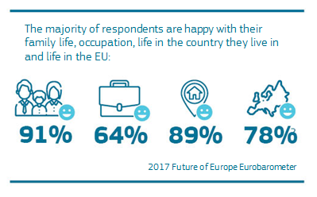

**The European Union is one of the best places to live**

* Nine EU-27 Member States rank amongst the 20 happiest countries in the world, with Finland topping the list.[4]
* Overall life satisfaction in the EU, based on subjective well-being of European citizens, is at 70%.[5]
* Eleven EU-27 Member States feature in the top 20 of the worldwide Youth Progress Index[6] from the European Youth Forum. The Youth Progress Index is one of the first instruments developed to give the full story of what life is like for a young person today, independent of economic indicators.

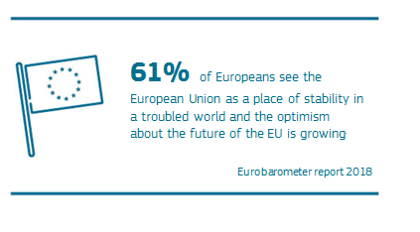

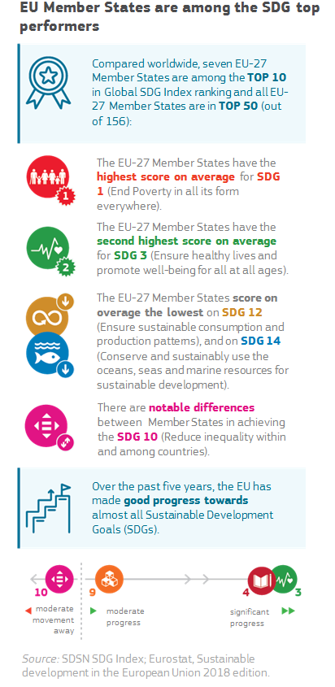

However, nothing is ever complete or permanently settled. Our democracy, our economy and our natural environment all need continuous efforts to consolidate our achievements, to fully overcome the negative impact from the economic and financial crisis, to decouple the improvement of our health, welfare and well-being from environmental degradation, to overcome social inequalities, and to address challenges that go beyond borders.

We are in the midst of the fourth industrial revolution and the changes will affect everyone. The question is whether we are going to be able to lead and guide the response according to our values and our interests. The EU and its Member States have significant competitive advantages allowing us to take the lead and modernise our economies, secure our natural environment and improve the health and well-being of all Europeans. To do so, will require us to embrace the SDGs whilst further investing in skills, innovation and emerging technologies, helping to drive the transition of our economy and society on to a sustainable path.

We have to consider how to evolve our production and consumption patterns. We must act now to stop global warming and the loss of ecosystems and biodiversity, which are threatening our well-being, the prospects for sustainable growth, and life itself on this planet. While we have the capacity to do so, we do not have the luxury of time. Inequalities and territorial disparities are still wide spread in spite of progress achieved. Addressing these is important for a fair society, but also for safeguarding and bolstering social cohesion, and securing social and political stability in and between the Member States in the EU.

In addition, a respected and effective rules-based multilateral world order is the best antidote to the law of the jungle in an anarchic world rife with nuclear weapons, extremism, and limited resources. There is a growing dangerous nationalist strain of ‘my country first’ that can lead to strife and conflict. Several countries have started turning their backs on their global commitments to human welfare, security, environmental protection and climate action, upending a rules-based order.

The SDGs are not an objective in themselves, but they serve as our compass and map. They offer the necessary long-term perspective, which transcends the electoral periods and short-term quick-win considerations. They help guide us to uphold robust democracies, build modern and dynamic economies, and contribute to a world with improved living standards, narrowing inequalities and ensuring that no one is left behind, whilst truly respecting the limits of our planet and securing it for future generations.

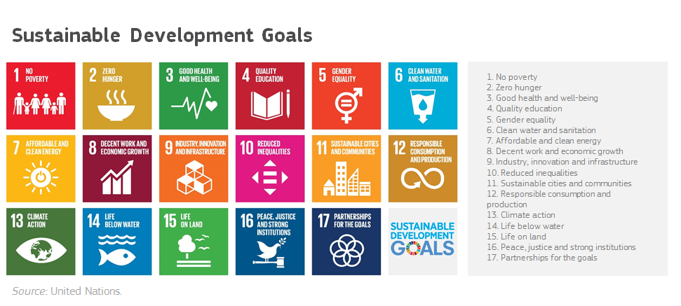

Since the start of its mandate, the Juncker Commission has worked to mainstream sustainable development in its policies[7] and has already laid the ground for the next generation of sustainable policies: from the European Pillar of Social Rights, the new European Consensus on Development to the values-based Trade for All Strategy, Strategic Engagement for Gender Equality and a European Education Area; from the Circular Economy package, ‘Europe on the Move’ packages and Energy Union to the Blue Growth Strategy and the Bioeconomy Strategy; and from the Investment Plan and Action Plan on Sustainable Finance to the Urban Agenda for the EU and Nature Action Plan, amongst others.

The Juncker Commission has also proposed to make the EU’s finances more sustainable by strengthening the link between EU funding and the rule of law, as well as through a more ambitious target of 25% for climate expenditure in the future EU budget.

Recently the Juncker Commission presented a long-term strategic vision for a prosperous, modern, competitive and climate neutral EU economy by 2050.[8] This vision paves the way for a structural shift of the European economy, driving sustainable growth and employment.

All these strategic policies will need to be fully and unambiguously implemented on the ground. They will also need to be complemented by further action, recognising the fact that all policies are interdependent, while taking into consideration new challenges, and new facts and evidence as they emerge. Social dialogue as well as voluntary measures from the private sector also have an important role to play in this respect.

The EU is exceptionally well-positioned to lead. A political vacuum is opening up as a result of the retreating policies of other world powers. This is an important opportunity for the EU to show leadership and blaze the trail for others to follow.

In May this year EU citizens will elect a new European Parliament. A new Commission is due to take office this fall. The end date of the “Europe 2020 strategy” for smart, sustainable and inclusive growth[9] is approaching fast. We must therefore look ahead to the next five-year policy cycle for Europe and the new Multiannual Financial Framework which runs from 2021 to 2027. The European Council[10] welcomed the intention of the Commission to publish this Reflection Paper, which should pave the way for a comprehensive implementation strategy in 2019. This Reflection Paper launches a debate on further developing the EU’s sustainable development vision and the focus of sectoral policies after 2020, whilst preparing for the long term implementation of the SDGs.[11] The Commission would like to contribute to a truly comprehensive and forward-looking debate on the future of Europe, and sustainable development is inextricably linked with that future.

# EU and global challenges to tackle

Following reform efforts at all levels, the EU's economic fundamentals have picked up after the economic and financial crisis.[12] However, recent forecasts[13] point to the need to increase growth rates, reduce debt rates, and sustain fiscal discipline in order to provide the framework for a robust economy. Unless we take steps to increase economic resilience and cohesion and address structural vulnerabilities, the coming years could lead to a loss of momentum amid large downside risks. Conversely, if we make the necessary structural reforms, we can deliver greater well-being and a stronger future, including through investment in research and innovation, public services, welfare systems and environmental protection. Steps both at EU and Member States’ level are necessary to ensure future-proof fiscal and pension systems, including stable tax revenues in the Single Market.

In addition, there are many challenges that have become increasingly pressing, and threaten our well-being and economic prosperity. All these challenges are complex and strongly interlinked, meaning that addressing one may have positive implications for others.

The most serious sustainability deficit and our greatest challenge is the ecological debt, which we are running up by overusing and depleting our natural resources and thereby threatening our ability to meet the needs of future generations within the limits of our planet. Worldwide, the strains on key resources, from fresh water to fertile land, put human existence in peril. Today humanity uses the equivalent of 1.7 Earths.[14] With the global consumption of material resources increasing fourteen-fold between 1900 and 2015, and projected to more than double between 2015 and 2050,[15] the world is quickly moving towards several tipping points. In addition to the environmental strain, this poses a serious challenge to the EU economy, which is dependent on materials from international markets.

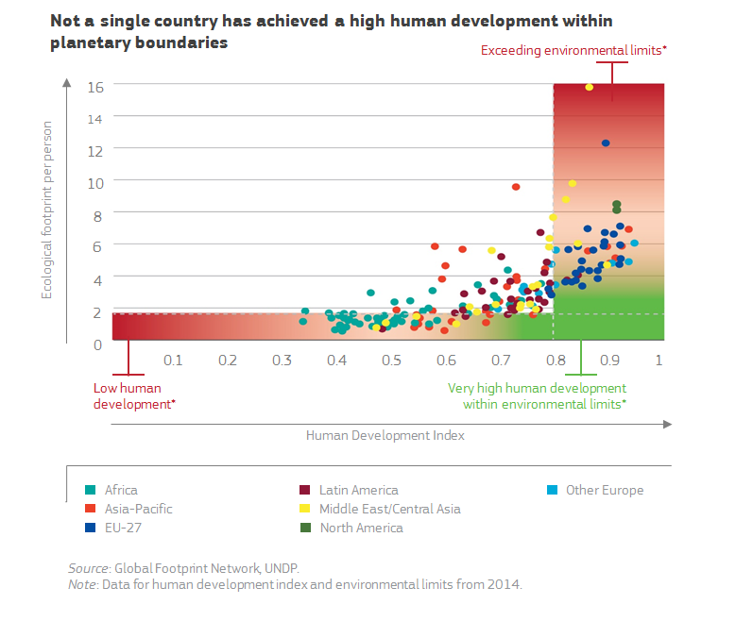

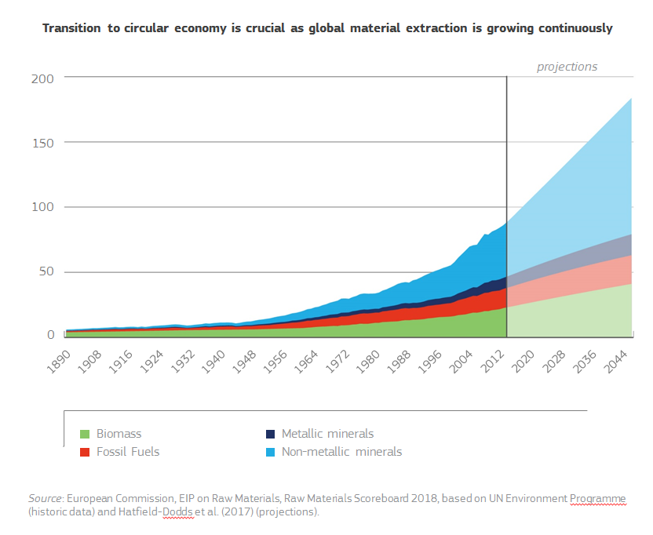

Biodiversity and ecosystems are increasingly threatened by human actions; in just 40 years world vertebrate species populations have declined by 60% on average.[16] Tropical forests are being destroyed at fast rates, with an area approximately the size of Greece lost every year.This is not 'somebody else's problem'. In the EU, only 23% of species and 16% of habitats are in good health. Animal-based food has a particularly high land-use footprint[17] and the growing demand for seafood puts significant pressure on marine ecosystems.[18]

Global greenhouse gas emissions continue to rise at an alarming rate, with energy use but also overconsumption of resources and destruction of ecosystems as key drivers. Transport is responsible for 27% of the EU's greenhouse gas emissions, and many urban areas are in breach of agreed EU air pollution limits. Food production is still a significant consumer of water and energy and emitter of pollutants, being responsible for approximately 11.3% of EU greenhouse gas emissions. In the EU fossil fuels continue to benefit from public subsidies of around EUR 55 billion per year, or some 20% of the EU’s fuel import bill, in spite of the EU’s ambitious decarbonisation measures and subsidy phase-out commitments in the G7 and G20.[19]

Overall, the EU has managed to reduce its own emissions, and decouple them from economic growth, thus robustly contributing to the global effort, also taking into account emissions embedded in the EU’s imports and exports.[20] However, both at the EU level and globally more efforts are needed.

If left unaddressed, the devastating impact of climate change and degradation of natural capital will seriously impact the economy, reduce the quality of life all over the planet and increase the intensity and frequency of natural disasters, putting more lives in jeopardy. While turning these negative trends around comes at a cost and requires strong collective effort, the cost of inaction and the associated social fallout would be much higher.[21]

As well as a planetary challenge, the EU’s social welfare model – a cornerstone of the European project – finds itself on shifting ground. Technological, structural, and demographic changes in a globalised world are transforming the nature of work and calling into question our solidarity, eroding the promise that each generation can hope to inherit a better world than the last. This could also increase the threat to the EU’s core values of democracy, rule of law and fundamental rights.

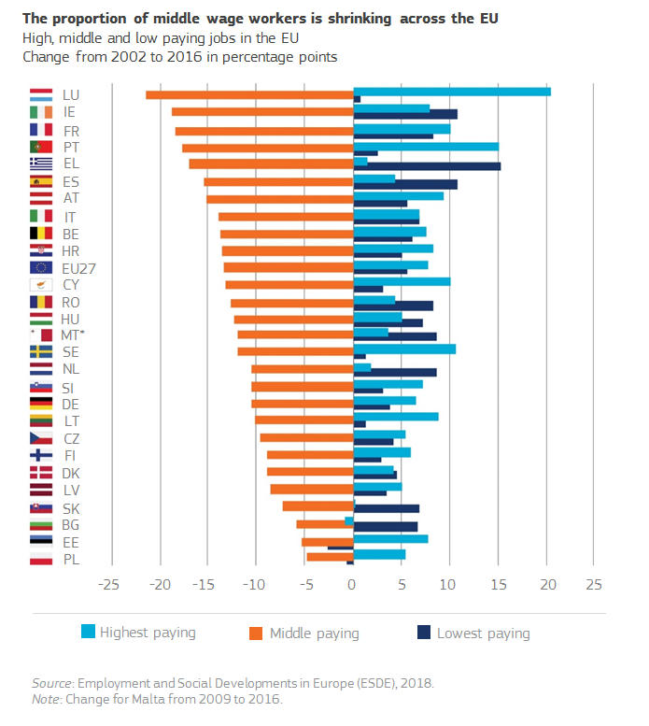

Currently, around 22.5% of the EU population is still at risk of poverty or social exclusion and 6.9% of Europeans still suffer severe material deprivation. In 2017, income inequality in the EU Member States declined for the first time since the financial crisis. However, inequalities in earnings are still too large with a continued concentration of wealth at the top. This has multiple social consequences, leading to differences between well-being and quality of life. EU Member States also face a number of challenges in securing affordable energy for all Europeans, with millions struggling to keep their homes warm.[22] While around 43 million people in the EU cannot afford a regular quality meal every second day,[23] we waste approximately 20% of our food production[24] and more than half of the EU's adult population is overweight,[25] increasing serious health risks. An additional health risk is antimicrobial resistance, which could cause more than 10 million deaths per year in the coming decades.[26]

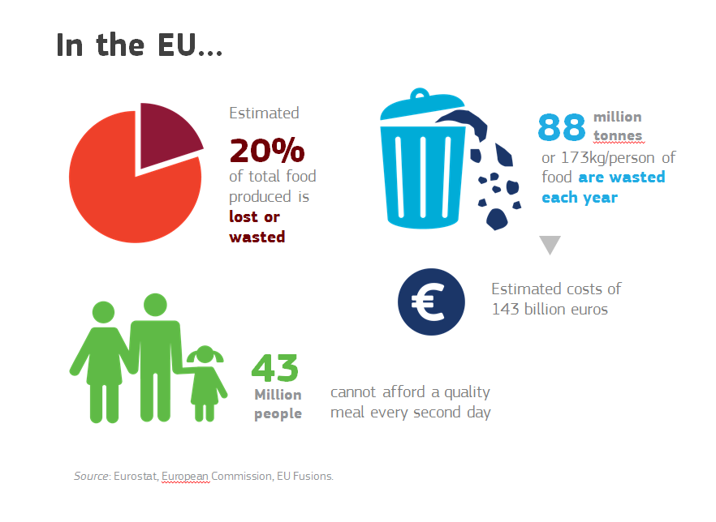

Today, there is still no full equality between women and men. Notwithstanding the fact that employment rates of women are at historically high levels and more women are present in positions of power than ever before, progress is stagnating or even regressing in other areas.[27] Twelve EU Member States have moved backwards in the past ten years when it comes to the gender balance of time spent on care, domestic work and social activities. Gaps in employment and pay persist.[28]

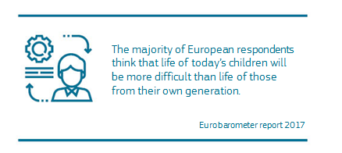

It is a great achievement that Europe has the highest life expectancy in the world. But a growing number of older people and a shrinking of the working age population brings its own challenges for our socio-economic model. Ageing coupled with longevity and increased likelihood of chronic diseases can have a deep impact on public finances, including on health systems. This will also increase the risk of inequality between generations.

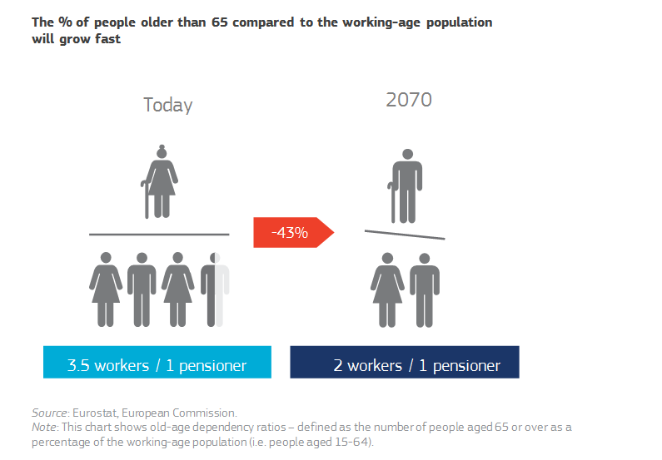

Inequalities and the decline in social mobility pose a risk to our overall economic development[29] and social cohesion. The EU generally fares relatively well with regard to income inequality but less well with regard to equality of opportunity. Inequalities of opportunity can impede parts of the population from social and labour market inclusion, hampering growth prospects.Addressing inequalities is crucial for the public to support the sustainability transition. The rising temptations of isolationism and nationalism may be a sign that too many Europeans do not feel well protected in a world that seems to them increasingly unfair. However, it is clear that alone no Member State is big or strong enough to tackle transnational challenges but united in the EU we can offer protection.

Inequalities at a global scale are reason for deep concern as well. With great differences in population growth and living standards across the world, and with global temperatures continuing to rise and ecosystems disappearing, we will inevitably see an increase in forced displacement and migration across the globe. For example by 2050, it is estimated that hundreds of millions of people will flee their homes as a result of climate change and environmental degradation.[30] This is a clear example of how the many different complex issues are interlinked and interdependent, and why they require a comprehensive response. There is simply no silver bullet or easy solution to any of the big and difficult challenges.

It is a daunting task to modernise our economic model, to address the social issues we face and to continue to nurture and foster a strong rules-based multilateral cooperation. Yet, these are the necessary ingredients to secure social stability, to let our economies thrive, and to improve our health. Our free societies require economic dynamism, continuous investments in key enabling technologies and in education. For a better future for all, we need a reinvented form of sustainable growth, based on the understanding that the natural boundary conditions of the 21st century are very different from those of the previous century. We welcome this challenge.

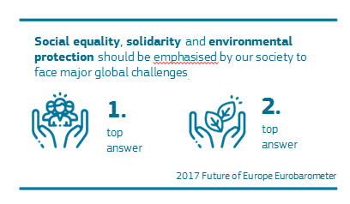

The SDGs are by definition global goals, applicable to all parts of the world, and we must address them in this way. We must work with an international perspective in mind, leading by example, setting global standards, and enticing countries, industries and people to join this quest. As the world’s largest single market, its largest trader and investor and the largest provider of development assistance, the EU can have a very significant influence on the success of the United Nations 2030 Agenda. The EU has already put in place many of the most modern policies in the world to foster sustainability. We must continue on this path, but the pace must be stepped up to ensure a sustainable Europe by 2030. We cannot afford passing the responsibility to next generations, and our margin of time is becoming ever smaller. The decisions we do or do not take in the next years will determine whether or not we can reverse these trends.

# Moving towards a sustainable Europe by 2030

Sustainable development is about upgrading people’s living standards by giving people real choices, creating an enabling environment, and disseminating knowledge, and better information. This should lead us to a situation where we are “living well within the limits of our planet”[31] through smarter use of resources and a modern economy that serve our health and well-being.

We should therefore continue on the path that we set ourselves: a transition to a low-carbon, climate-neutral, resource-efficient and biodiverse economy in full compliance with the United Nations 2030 Agenda and the 17 SDGs. This transition needs to be for the benefit of all, leaving no one behind, ensuring equality and inclusiveness. Our economic growth must depend less on non-renewable resources so that we maximize the use of sustainably managed renewable resources and ecosystem services.

The EU has already embarked on this transition. Between 2000 and 2015, employment grew at a faster rate in the environmental sector than in the economy overall.[32] Low-carbon technologies are becoming a major trade commodity, with the EU benefitting from significant positive trade balances. During the period 2012-2015, EU exports of clean energy technologies reached EUR 71 billion, exceeding imports by EUR 11 billion. The EU is already showing that it is possible to grow the economy, and reduce carbon emissions at the same time.

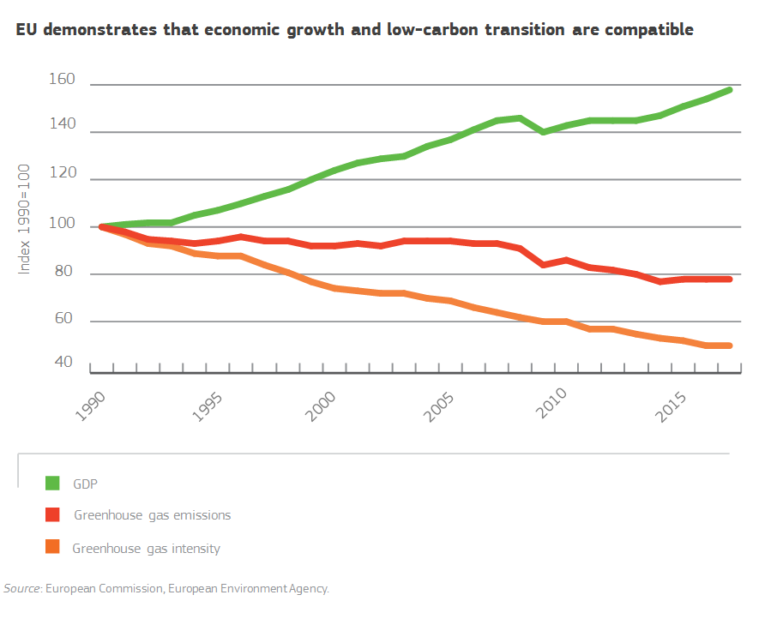

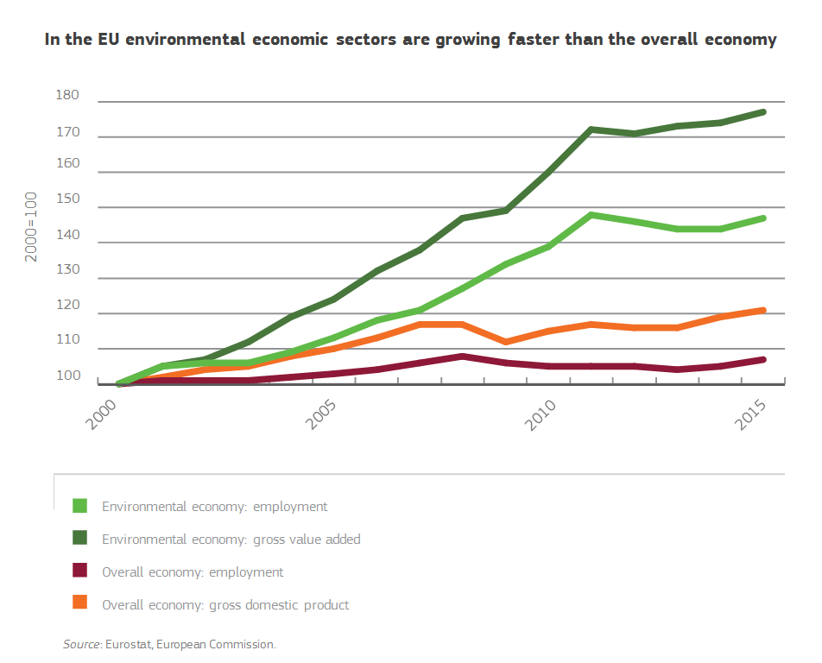

The EU can set the standards for the rest of the world if it takes the lead in the implementation of the SDGs and the transition to a sustainable economy, including through smart investments in innovation and key enabling technologies. The EU would then be the first to reap the benefits of the transition. It would also have the strongest competitive advantage in the global marketplace of tomorrow. This will contribute to building stronger Member States in a stronger Union, helping people pursue their goals in freedom and well-being, and thus fulfilling Europe’s vision.

“Green growth would ‘lift all the boats’”,[33] benefitting producers and consumers alike. It is estimated that achieving the SDGs in the areas of food, agriculture, energy, materials, cities, and health and well-being could open more than EUR 10 trillion of market opportunities.[34] The EU’s ambition to achieve a resource-efficient and climate-neutral economy will demonstrate that a green transition can go hand in hand with increased prosperity. To succeed, the EU and its Member States must lead the way in science, technology, and modern infrastructure. We must also encourage the emergence of new business models, bring down the barriers in the Single Market and take advantage of new technologies such as artificial intelligence. Important horizontal enablers such as research and innovation, finance, pricing and taxation, responsible business conduct, and new business models and education will create the right conditions for sustainability change if they are geared towards an innovative green, inclusive and socially just economic transition.

To get there, we need to continue investing in people and in the different systems that underpin our society. Isolated, piecemeal approaches have proven to be ineffective. We need to formulate strategies that are comprehensive and integrated. For instance, environmental issues cannot be solved with environmental policies alone if economic policies continue to promote fossil fuels, resource inefficiency or unsustainable production and consumption. Similarly, social policies are not sufficient to accompany the fourth industrial revolution and support the labour force affected by the carbon-transition; strong education and training policies as well as research and development will be of crucial importance too to build the necessary resilience in our societies.

Action is needed at all levels. EU institutions, Member States and regions will have to be on board. Cities, municipalities and rural areas should all become drivers of change. Citizens, businesses, social partners and the research and knowledge community will have to team up. The EU and its Member States will have to work together with international partners. If we are to succeed, we must pull in the same direction at all levels.

## Policy foundations for a sustainable future

It is therefore of the utmost importance that all actors in the EU prioritise the sustainability transition. They must further develop the cross-cutting policy agendas that have been adopted at the EU level in recent years. Significant parts of EU policies are already geared towards achieving the SDGs, but they still need to be put into practice in an integrated way by the Member States. For example, the costs of not implementing existing EU environmental legislation are broadly estimated at around EUR 50 billion a year in health costs and direct costs to the environment. Achieving full compliance with EU environmental rules would not only bring vast benefits for the environment, and our health but also create jobs.[35]

In the same vein, it is not just about speeding-up and scaling-up of sustainable solutions, but also about building bridges and increasing coherence between different agendas at all levels. Policy coherence is a critical condition to ensure that we can deliver on the SDGs and ensure long-term green and inclusive growth for the EU.

In line with the strong evidence base of the key sustainability challenges and opportunities for the EU, it is important to focus on production and consumption in the areas of materials and products, food, energy, mobility and the built environment,[36] taking into account the social implications of the changes in these areas. This is where sustainability changes are most needed and are potentially most beneficial for the EU economy, society and natural environment, with strong positive global spillover effects. These areas do not operate in isolation but are strongly interlinked and mutually reinforcing.

### From linear to circular economy

Increasing availability and affordability of different materials and products have simplified our lives and contributed to the rise in living standards and the quality of life in the EU. However, our culture of consumption has resulted in excessive resource extraction and growing pressures on natural capital and climate.[37]

We need to make sure that we can continue to grow our economy in a sustainable way and improve the living standards people demand. This will require new designs of materials and products so that we are properly equipped to re-use, repair and recycle more and more. This will in turn not only cut waste, it will also reduce the need for new resources to be extracted at great financial and environmental cost. When a product reaches the end of its life, be it a pair of jeans, a smartphone, food container, or piece of furniture, a true circular economy ensures that most of its material value is preserved, so what was previously considered waste can be used again for making new products.

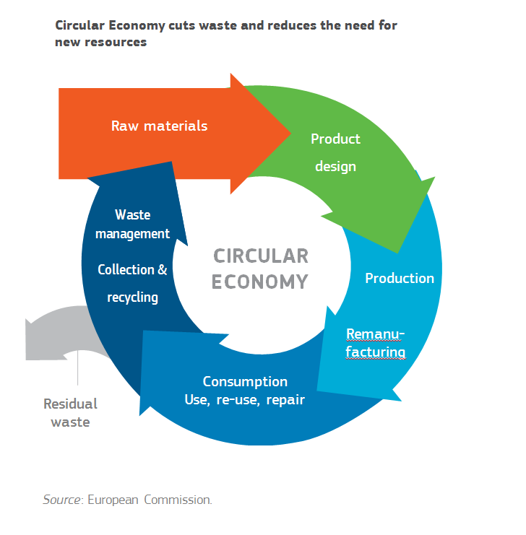

The **transition to a circular economy**, including to a circular bioeconomy, is a huge opportunity to create competitive advantages on a sustainable basis.Applying circular economy principles in all sectors and industries will benefit Europe environmentally and socially and in addition have the potential to generate a net economic benefit of EUR 1.8 trillion by 2030[38], result in over 1 million new jobs across the EU by 2030[39], and be central to cutting greenhouse gas emissions.[40] Given EU products’ heavy reliance on the resources of other parts of the world, the transition to a circular economy would also help the EU decrease environmental, social and economic pressures globally, and increase the EU’s strategic autonomy.

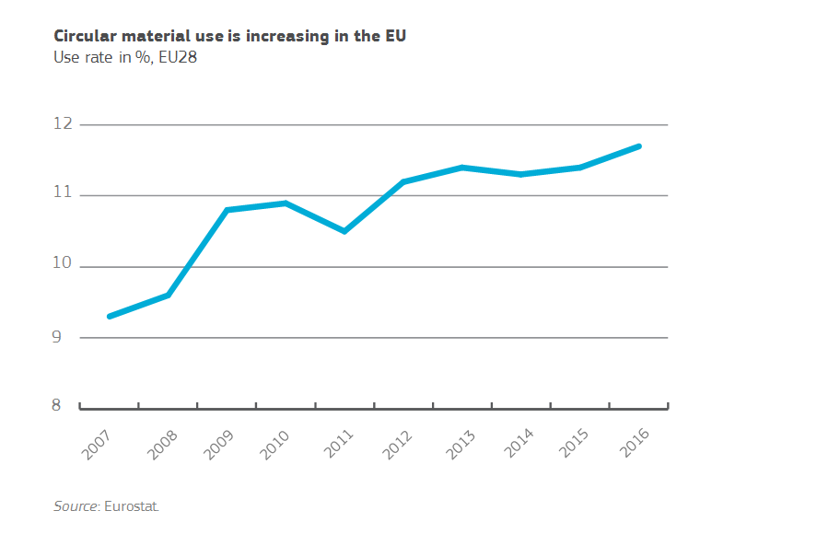

The EU is the best-placed economy to benefit from the circular transition by making circular products one of its flagship brands, generating competitive advantages. However, to maintain that advantage we will need to step up our efforts. The Circular Economy Action Plan adopted by the Juncker Commission in 2015 sets out measures to guide the EU economy towards a circular path and help the EU to become a world leader in this transition. It includes steps for changing consumption and production patterns, by focusing on the design of products (durability, reparability, re-use and recyclability), waste management (avoidance, material recycling, energy recovery and avoidance of landfilling) and increasing consumer awareness. Almost all elements of the Action Plan have already been delivered but more steps will need to be taken to build a fully circular European economy.

The renewed EU Bioeconomy Strategy presented in 2018 complements the Circular Economy Action Plan, improving and scaling up the sustainable use of renewable resources and allowing renewable raw materials and industrial by-products to be turned into bio-based products, such as fuels, chemicals, composites, furniture and fertilisers.

It is now essential to turn those policies that are in place into reality on the ground, and continue to prioritise new actions at all levels of EU governance. For instance, the ambitious modernisation of EU rules on waste will have to be put in practice by Member States. Life-cycle assessments of products should become a norm and the eco-design framework – created for increasing the efficiency of products to reduce energy and resource consumption – should be broadened as much as possible. The work started on chemicals, the non-toxic environment, eco-labelling and eco-innovation, critical raw materials and fertilisers, needs to be accelerated. Boosting the market for secondary raw materials has to remain a high priority. The successful work on a circular plastics economy will have to remain a key focus area, and additional resource and pollution-intensive industries such as food, textiles, and electronics will also have to be supported and stimulated to become circular. Bio-based sectors have to be scaled up and strengthened while protecting our ecosystems and avoiding overexploitation of natural resources. Moving forward, we should make the circular economy the backbone of EU industrial strategy, enabling circularity in new areas and sectors, empowering consumers to make informed choices and enhancing efforts by the public sector through sustainable public procurement. The time is right, and the groundswell of public support for the EU Plastics Strategy shows there is an increasing understanding for continuing on this path.

**Circular economy in action: EU putting in place the world’s first comprehensive Plastics Strategy**

The EU Plastics Strategy[41] and legislation on single-use plastics[42] will protect the environment from plastic pollution while fostering growth and innovation. All plastic packaging placed on the EU market will need to be recyclable by 2030 in an economically viable manner, intentionally added microplastics and the most harmful single-use plastic items for which alternatives exist will be banned, and recycled plastics will be increasingly used to make new products.

### Sustainability from farm to fork

The EU's farm sector and rural areas are crucial for the well-being of Europeans. Our agriculture and food industry make the EU one of the world's leading producers of food, guarantor of food security and provider of millions of jobs for Europeans. The EU's farmers are also the first stewards of the natural environment, as they care for the natural resources on 48% of the EU's land, with foresters accounting for a further 40%. The EU's rural areas are hosts to innovative sectors such as bioeconomy. Moreover, our rural areas serve as major bases for recreation and tourism. However, as average temperatures continue to rise and the natural environment is degraded, farmers and foresters are most directly affected.

EU agriculture has made real progress on the climate and environment front, reducing greenhouse gas emissions by 20% and nitrates levels in rivers by 17.7% since 1990. Nevertheless, the identified challenges remain. If we are to modernise our economy, protect our environment and improve the quality of our food, imbalances in our food chain need to be corrected, from agriculture and fishing, to the food and drink industry, transportation, distribution, and consumption.

The SDGs offer the way forward. It is estimated that a global food and agriculture system in line with the SDGs could create new economic value of more than EUR 1.8 trillion by 2030.[43] It could deliver nutritious, affordable food for a growing world population, generate higher incomes, help restore forests, freshwater resources and ecosystems, and be much more resilient to climate risk.[44] Sustainable agricultural and food production practices are expected to create over 200 million full-time jobs globally by 2050.[45]

Here too public demand is evolving. Citizens increasingly value food produced with broader benefits for society, such as organic produce, products with geographical indications, localised food production systems with lower carbon footprints, and innovative low-emission food solutions. Organic farming, with an emphasis on environmental protection and animal welfare, has been steadily increasing in all EU Member States since 2005 and is expected to keep growing.[46]

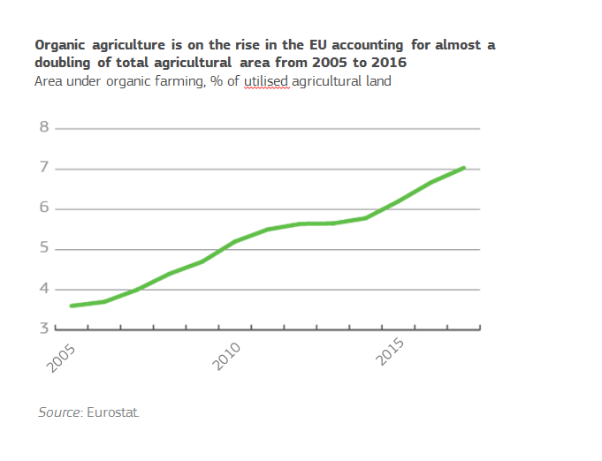

As the number one exporter and importer of agri-food products in the world,[47] the EU is well-positioned to reap the benefits of this economic opportunity and become a global sustainable food champion. This can be achieved. We need a comprehensive approach entailing a genuine change in the way we produce, transform, consume and distribute food by accelerating the transition to a **sustainable food system** based on circular economy principles and making innovative, healthy, environment and animal welfare-friendly, safe and nutritious food production one of our key European trademarks.

The Commission has proposed a modernised Common Agricultural Policy (CAP), where Member States’ national plans will have to reflect the strong sustainability principles embedded in the CAP objectives. The Common Fisheries Policy has led to significant progress in improving the sustainability of European fisheries. However, proper implementation of the Common Fisheries Policy, including the sustainable management of all fish stock and the development of sustainable aquaculture remains essential.

**Box: Support for the transition to sustainable agriculture through a modernised CAP**

The future CAP (2021 to 2027)[48] will continue to ensure access to high-quality food and strong support for the unique European farming model with an increased focus on the environment and climate, supporting the continued transition towards a more sustainable agricultural sector and the development of vibrant rural areas.

New obligations include preserving carbon-rich soils through protection of wetlands and peatlands; an obligatory nutrient management tool to improve water quality, reducing ammonia and nitrous oxide levels; crop rotation instead of crop diversification. All farmers who benefit from CAP support will have to respect these basic standards.

Each Member State will have to develop eco-schemes to support and/or incentivise farmers to give preference to agricultural practices that are beneficial for the climate and the environment, beyond their mandatory requirements. Additionally, farmers will have the possibility to contribute further to enhanced sustainability by receiving additional support through various voluntary schemes.

In this context, it is important to enforce a more prudent use of antimicrobials so as to lower the risk of further antimicrobial resistance in animals and humans[49], pursue the EU Action Plan to fight food waste, increase the focus on animal welfare standards, ensure sustainable use of pesticides and turn bio-waste, residues and discards into valuable resources. Creating transparency of value chains and incentivising producers and supermarkets to offer, and consumers to choose sustainable food and healthy diets could be encouraged through appropriate and innovative measures including better education and consumer information to offer real, affordable, healthy choices. Shifting to a more sustainable consumption of animal-based products would in addition bring significant health benefits for consumers and positively affect the natural environment.[50]

### Future-proof energy, buildings and mobility

**Clean energy** is key to a sustainable future. We need to produce, store and consume energy in a sustainable way to reduce our environmental impact and protect the health of Europeans.

The EU is already one of the most carbon efficient economies in the world. Renewable energy is an integral part of Europe’s energy mix and more than half of the EU’s electricity supply is climate-neutral. Energy efficiency measures, including energy labelling, have reduced energy consumption in recent years.[51]When buying appliances people increasingly choose the energy efficient option. There are nearly 1.5 million jobs in renewable energy and energy efficiency in Europe.

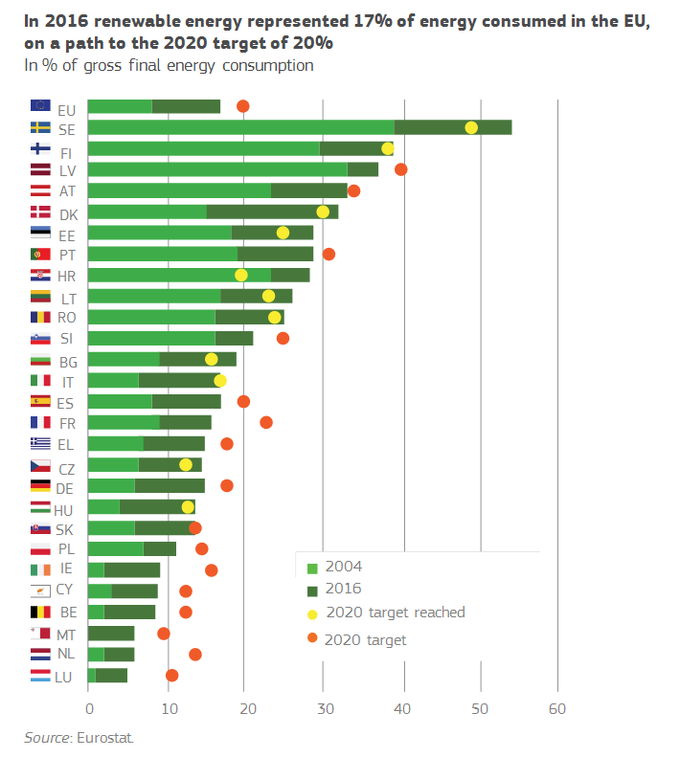

With the Energy Union, the European Commission has put in place one of most comprehensive global policy frameworks for the energy transition and economic modernisation, bringing together climate, energy, transport, research and other policies. As part of Energy Union regulation, the EU level targets of reaching at least 32% renewable energy of total energy consumption and at least 32.5% energy efficiency in 2030 will allow us to go beyond our commitment under the Paris Climate Agreement to reduce greenhouse gas emissions by at least 40% by 2030, compared to 1990 levels.

**Box: Clean Energy is an opportunity for jobs and growth**

Between 2008 and 2014 the number of jobs in renewable energy technologies increased by 70%. There is potential to create an additional 900,000 jobs by 2030, provided that public and private investment is mobilised. Up to 400,000 additional local jobs could come from the energy efficiency sector.

Beyond 2030 more is needed to live up to the letter as well as the spirit of the Paris Climate Agreement, exploiting the full economic potential of the energy transition. The EU can significantly decrease its costly dependency on fossil fuels, reduce its fossil fuel import bill of some EUR 260 billion, increase its energy autonomy, and contribute to a fairer energy market.It is essential that we continue the integration of the energy market by building the missing interconnections and facilitating cross-border energy trade. The clean energy transition can also be supported by ocean energy and offshore wind energy. As a leader in this field, the EU should continue enjoying its first-mover advantage.

As **buildings** are responsible today for around 40% of energy consumption, there is a need to promote improved energy efficiency of buildings through renovation and modernisation. This has already begun. For example, eco-industries linked in particular to the refurbishment of buildings represent more than 3.4 million jobs in Europe. Reducing energy demand in buildings requires increased use of efficient and clean electric heating, but also smarter buildings and appliances and improved materials for insulation, fully in line with the circular economy principles. The Energy Performance of Buildings Directive aims to improve the quality of living, by making our houses better insulated and ventilated and thus better places to live, while decarbonising our building stock by 2050. Such actions will lead to cheaper living costs and thus leave more money in people’s purses. Ways and means, however, must be found to help people make that transition in the first place.

Another main driving force for the transition towards a clean, resource efficient and carbon-neutral future is the **mobility** sector, from urban mobility to trans-European networks, road transport as well as shipping and aviation. Transport and mobility services employ around 11 million people, and demand for mobility today is high. However, transport today generates air pollution, noise, congestion and road accidents. The sector already represents almost a quarter of Europe's greenhouse gas emissions and its emissions’ footprint is rising. The Action Plan for Low Emission Mobility, presented by the Commission in 2016, and the ‘Europe on the Move’ proposals which followed, foresee numerous measures to increase the sustainability of our transport system. These actions are geared towards reducing greenhouse gas emissions and giving a signal to EU companies to invest in clean transportation. This too will contribute to jobs and growth. We need to prioritise clean and affordable alternatives, with an objective to have only zero emission vehicles on EU roads and make the best use of digital technologies to help reduce fuel consumption. Likewise, the EU’s satellite navigation systems contribute to reducing emissions, for instance in aviation and road transport.

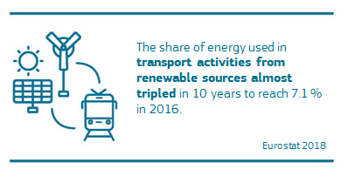

Cities are the vanguard of the shift to sustainable mobility. Through sustainable urban planning, integrating spatial planning and addressing mobility demands and infrastructure, cities have an important role to play. Urban areas should also be assisted in digitisation, automation and other innovative solutions and should pursue active and shared transport, from more walking and cycling to car-sharing services and car-pooling.

Additionally, it is important to look at the design and the end-of-life of vehicles, and at transport infrastructure to make sure that the opportunities of circular economy transition are used to the maximum. Vehicles that have reached the end-of-life still contain many valuable materials. The EU end-of-life vehicles legislative framework requires producers to design and manufacture new vehicles without hazardous substances and in such a way that makes it easy to reuse and recycle the materials of an old vehicle to make new products.

More can and should be done from using recycled content in vehicles and transport infrastructure to reaching more efficient recycling. **For example, increasing the collection and recycling rates of electric car batteries in the EU could reduce dependence on imported materials and help to retain the value of recovered materials in the EU economy**. Additional incentives, both regulatory and financial, will be important to make the most of the circular economy potential in the transport sector.

### Ensuring a socially fair transition

Solidarity and prosperity are virtues in themselves and make up the very fabric of our free and democratic societies. The transition to ecologically sustainable economic growth and competitiveness can only be successful if it is inclusive at the same time. Sustainability change is therefore also about **promoting social rights and well-being** for all and in turn contributing to social cohesion in the Member States and across the EU.

The sustainability transition can have strong positive spill-over effects on social well-being. In addition to providing the foundation for decent jobs, it can have notable health benefits too. It is widely recognised that good health is closely connected to the state of our natural environment. The detrimental effects of air and water pollution are a prime example in this regard. Sustainable food systems can provide high quality nutritious food to all citizens.

**Box:** EU legislation on chemicals has significantly contributed to ensuring a high level of human health protection. Over the past four decades, human and environmental exposures to hazardous substances have dramatically decreased. EU legislation has also helped to reduce the exposure to certain carcinogens in the workplace and led to an estimated prevention of one million new cancer cases in the EU over the last 20 years.

Creating synergies and modernising our economy also sometimes entails difficult trade-offs. Whereas in the sustainability transition new jobs will be created, traditional jobs may disappear or be transformed including through digitisation and automation, creating temporary friction in the labour market. With regard to the labour market it is for instance at present unclear what the exact impact of artificial intelligence will be.

Despite the fact that many households are struggling to make ends meet, there is a growing public understanding that we need to change the ways we produce and consume. Nevertheless, not only can these challenges hit the middle and lower-income class relatively harder but the costs to upgrade their houses, their cars or their skills, for example, can pose a higher burden on them as well.

This transition has consequences for those employed in affected businesses and sometimes for entire regions. A fundamental principle to enable the transition is to leave no one behind. We simply cannot succeed with the sustainability transition at the expense of groups of people, communities, sectors or regions. All members of our society will have to receive equal opportunities to contribute to a sustainable European future and benefit from the transition. We must in particular empower women to enter the job market and seek economic independence.

To succeed in putting our society on a sustainable path, we must ensure that our policies help all Europeans make this change, including by equipping them with the necessary skills. The Commission launched, for example, the Coal Regions in Transition initiative, which helps develop strategies and projects for viable social, economic and technological transformation in certain regions in the EU, and which will be extended to carbon intensive regions. Such early initiatives that anticipate transition challenges should be reinforced and multiplied to other sectors where transformation is needed. Automotive and certain food sectors could be an example.

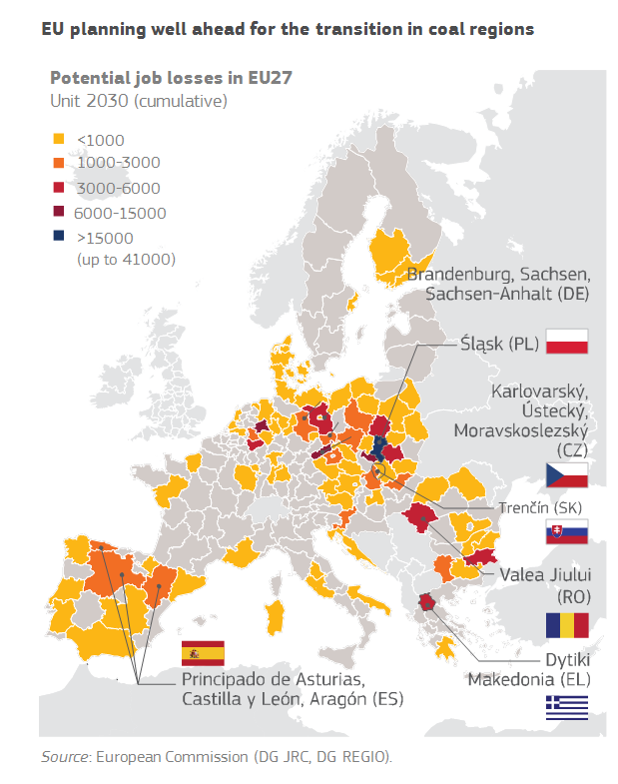

Ensuring a socially inclusive, just and fair transition will also be crucial for the public acceptance of the steps required and for turning the transition into a success for all. This implies a higher and fairer participation in the labour market, while focusing on job quality and working conditions. It also implies the respect for minorities’ rights.

In this context, orderly, legal, and well-managed migration can create opportunities for the European economy, addressing changing demographics, both in countries of origin and in countries of destination of migrants. Integration and full participation in societies – be it cultural, social or economic – of all migrants who are rightfully and legitimately resident in the EU is a common responsibility and is crucial to ensure social cohesion.[52]

The sustainability transition also requires investment in effective and integrated social protection systems, including quality services such as education, training, life-long learning, childcare, out-of-school care, health and long-term care. This is essential to ensure equal opportunities for all and to promote economic and social convergence. Healthsystems, in particular, need to evolve so that they are easily accessible and affordable to all, including improved access to medicines, more patient-centred, and strongly focussed on health promotion and disease prevention. They should also have more and better planning and forecasting on health workforce and a broader use of cost-effective digital technologies.[53]

Social investment must therefore remain among the top priorities of the EU and its Member States. The Reflection Paper on Social Europe[54] is an important reference point, and explores in detail the options for adapting our social models to the challenges we face. The main framework for the EU in moving ahead is the European Pillar of Social Rights proclaimed by the EU institutions in November 2017. The Pillar’s purpose is to guide a renewed process of improving working and living conditions. It sets out key principles and rights in the employment and social field. Our focus must now be on delivering on the Pillar. Moving forward, we also have to make sure that the Pillar’s implementation will help equip people with the right skills for the right jobs that are geared towards green economic transition.

The sustainability transition must also continue to help Member States and regions grow upwards and towards one another, while avoiding wider regional injustice and inequalities in the EU within and between urban and rural areas.

While 75% of the EU territory is rural, urban areas are home to over two-thirds of the EU's population. They generate up to 85% of EU GDP, account for about 60-80% of energy use, and commonly face challenges such as congestion, a shortage of adequate housing, air pollution, and declining infrastructure.[55] The implementation and development of the Urban Agenda for the EU should remain a priority and synergies with different sustainability policies and other instruments should be intensified.

Rural areas are also the main suppliers of the food, energy and materials we consume, and are therefore critical for the sustainability transition. The bioeconomy is one example where an important contribution can be made to decarbonising our economy while creating rural jobs. Sustainable tourism and food systems are also good examples of economic opportunities in rural areas, involving the protection and enhancement of cultural and natural heritage.

EU measures alone, such as cohesion policy and rural development policies, including the EU Action for Smart Villages, will not be enough, and all actors, including national and regional, will have to do their part to accelerate the sustainability transition and apply the appropriate regulatory and other approaches that strengthen rural areas and safeguard equal living conditions.

## Horizontal enablers for the sustainability transition

### Education, science, technology, research, innovation and digitisation

Education, science, technology, research and innovation are a prerequisite for achieving a sustainable EU economy meeting the SDGs.[56] We need to continue to raise awareness, broaden our knowledge, and hone our skills. We should invest more in these areas, gearing them towards the SDGs.

Education, training and life-long learning are indispensable to create a sustainability culture. EU leaders have agreed to work towards a European Education Area by 2025 to harness the **full potential of education, training and culture as drivers for job creation, economic growth and social fairness**. Education is both a virtue in itself, and an invaluable means to achieve sustainable development. Improving equal access to inclusive high-quality education and training at all stages of life, from early childhood through to higher education and adult education, must therefore be a main focus. Educational institutions of all levels should be encouraged to embrace the SDGs as guidance for their activities and supported to become places where skills for sustainability are not only taught, but also actively practiced. Reform and modernisation of education systems from building green schools and green campuses to developing new skills for the digital economy should also be addressed.

Enhancing ICT skills and core digital competences, in line with the EU Digital Education Action Plan,[57] and focussing on artificial intelligence[58] should be among the priorities when moving forward. Harnessing the power of the digital transformation to meet the SDGs is a clear priority. The EU is fully committed to develop capacity and expertise in key digital technologies such as connectivity, the ‘internet of things’, cybersecurity, blockchain or high-performance computing, while simultaneously paying attention to the potential negative externalities of digital infrastructures.

Artificial intelligence is an area where the EU is lagging behind China and the United States.[59] The EU needs to catch up quickly to reap the economic benefits and at the same time take the lead in shaping the necessary new ethics that should accompany this new technology. This way the EU can help ensure that artificial intelligence is a net benefit to people’s lives and work. By being able to process large amounts of data instantaneously, artificial intelligence has the potential to significantly increase productivity in many areas, such as healthcare, energy, agriculture, education and environmental protection. For instance, in the agricultural sector, researchers currently use artificial intelligence and big data to predict crop yields several months before harvest, thereby potentially helping farmers increase productivity, make informed planting decisions and ultimately enhance food security.[60]

Research and innovation have an important role as a catalyst for change. They are a tool for analysing the impacts of change and a means for ensuring that any transition leads to an increase in our well-being. They also allow us to save money. Investing more in innovation and technological development today will in the longer run help us to lower the costs of meeting our long-term policy goals such as those related to our climate and environmental targets. Europe has the brains, the skills, and the innate creativity. Building on the strengths of its rich community of researchers and innovators, the EU is in a strong position to take the lead in developing and deploying breakthrough solutions for green and inclusive growth that will be applicable in the EU as well as globally.

However, to fully exploit this potential EU Member States need to step up their research spending. The EU has agreed that by 2020, 3% of EU Member States' GDP should be invested in research, development and innovation, yet we are still far from reaching this target.

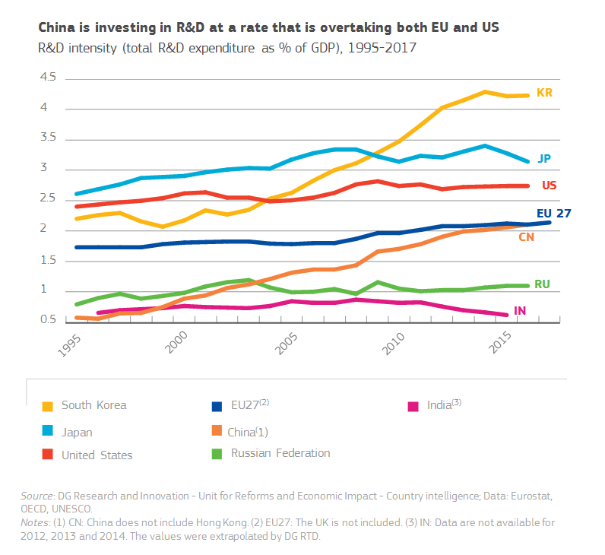

At the EU level, the Framework Programmes for Research and Innovation are a catalyst for sustainable competitiveness, growth and investments. To accelerate the sustainability transition, research and innovation funding needs to be complemented with a strategic approach to investment, allowing innovative solutions to reach the market, as these often require capital intensive and high-risk investments. Instruments such as the European Fund for Strategic Investments have been created to help lower the risks of such investments and thus make them more attractive to private stakeholders. The recently-proposed European Innovation Council can also help in that respect by supporting top-class innovators, start-ups, small companies and researchers to succeed with high-risk innovative projects, scale-up internationally and benefit from intellectual cross-fertilisation.

The EU and its Member States could focus on financing breakthrough and disruptive technologies and innovative companies that have the potential to become EU and global market leaders in the sustainability transition, as well as on the effective and timely up-take of these innovations. Particular attention should be paid to sustainable and innovative farming and food systems, clean technology, human and animal health, ecosystem solutions and resource-efficient products and production methods. Additionally, a supportive regulatory framework to stimulate the effective uptake of innovation for sustainable development is required.

The EU and its Member States would also need to promote stronger links between researchers and business. EU research, development and innovation hubs and incubators are important to support sustainable development, so researchers and businesses can meet, exchange best practises, and spur innovation. While large companies may have the means to develop their research activities in-house, this is often not the case for small- and medium-sized enterprises. Stronger and more direct links with the research community have the potential to bridge this gap.

Box: The European Institute of Innovation and Technology (EIT), with 40 Innovation Hubs across the EU, brings together the knowledge triangle of education, research and business. Several **Knowledge and Innovation Communities** (KICs) have been launched and more are to follow. These communities **address major EU societal challenges related to the SDGs**, like climate, energy, food, health, raw materials, digital, urban mobility and advanced manufacturing. More than 1200 partners from business, research and education come together to tackle these challenges.

### Finance, pricing, taxation and competition

The costs of doing nothing are huge in the medium- and long-term. At the same time, the sustainability transition entails significant investments in the short run and a comprehensive shift in how the financial system works. Achieving the SDGs is estimated to require around EUR 4.5 to 6 trillion globally.[61] Around EUR 180 billion of additional investments are needed to achieve the EU's 2030 targets agreed in Paris, including a 40% cut in greenhouse gas emissions. Public funds need to be better and more intelligently oriented towards the pursuit of the SDGs, but we cannot meet our needs without the private sector shifting to sustainability as well. Mobilising funding to finance transition has to go hand in hand with the phasing-out the funding of projects that are detrimental to a green and inclusive economic growth.

The Investment Plan for Europe aims to mobilise private finance for the public good. Launched in 2015, its financing arm, the European Fund for Strategic Investments, mobilised so far EUR 370 billion in total investment in key areas necessary for the modernisation of the European economy. This includes renewable energy, energy efficiency, research, development and innovation, as well as social infrastructure such as social or affordable housing. For the next budgetary framework from 2021 to 2027, the Commission proposed to double the budgetary resources for the social sector, including for social entrepreneurship, and finance sustainable infrastructures only. The European Investment Bank Group is already today the largest multilateral provider of climate finance worldwide, committing at least 25% of its investments to climate change mitigation and adaptation.

The Commission - based on recommendations from a high-level expert group - also set out a roadmap to boost the role of finance in achieving a well-performing economy that delivers on environmental and social goals. The Action Plan on Sustainable Finance[62] and the legislative proposals that followed will help investors to make informed investment decisions, based on clear criteria of what is a sustainable investment. This should facilitate speeding up and scaling up broader investments in sustainable projects both in the EU and worldwide, as well as incentivise investors to step out of investments that are unsustainable.

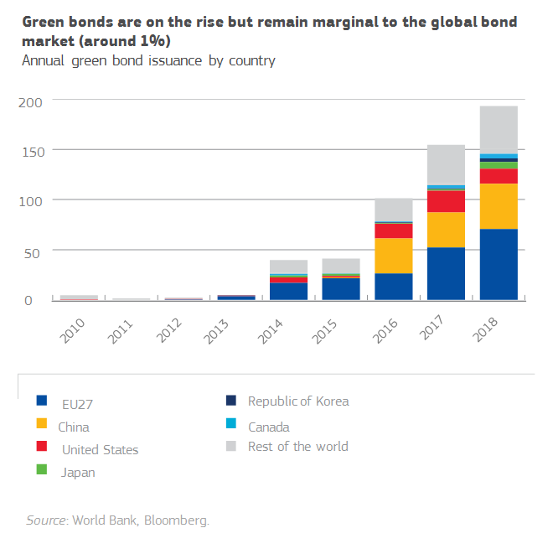

Further focus should be given to connecting sustainable finance to the real economy so that the increased demand for sustainable products and services from investors would be matched by an increased supply. Effective pricing of externalities will be key in that regard. Additional efforts should also be made to inform European citizens about the finance system, so they are more aware of the corporate activity they are funding and of how to hold fund managers to account in case their money is not managed sustainably.

**The EU is leading a comprehensive shift of the financial system to a sustainable path through:**

* **Establishing a common language**: a unified EU classification system ("taxonomy"), to define which economic activities are sustainable and identify areas where sustainable investment can make the biggest impact.
* **Reducing the risk of greenwashing**: creating standards and **labels** for green financial products allowing investors easily identify investments that comply with green or low-carbon criteria.
* **Incorporating sustainability in investment advice**: requiring insurance and investment firms to advise clients on the basis of their preferences on sustainability.
* **Developing sustainability benchmarks and fostering their transparency.**
* **Clarifying** **institutional investors and asset managers’ duties**: ensure they take sustainability into account in their investment decisions and enhance their disclosure requirements.
* **Enhancing** **transparency in** **corporate reporting**: revising the guidelines on disclosure of non-financial information.
* **Incorporating sustainability in prudential requirements**: inclusion of a green supporting factor when it is justified from a risk perspective to safeguard financial stability.

To safeguard public authorities' financial capacity to invest in the sustainability transition, action is also needed to achieve sustainable fiscal reform at all levels. We should strengthen the fight against tax evasion and corporate tax avoidance. Transnational cooperation is necessary to deal with the issue of tax havens that undermine the tax base of both the EU and developing countries.

More fundamentally, EU tax systems and pricing should be designed to reflect real costs, address our main social and environmental issues and trigger behavioural change throughout the economy. Sustainable competition depends on prices that reflect the true costs of production and use – internalising externalities.[63]

Regulators, business leaders and civil society need to work together to provide a level playing field in line with the SDGs and to stimulate development that leads sustainable products and services to become the most affordable ones.

This should involve changes in fiscal systems so that Member States reduce taxes on labour and increase them on capital, pollution, under-priced resources and other environmental externalities.[64] The “user pays” and "polluter pays" principles have to be applied to prevent and correct environmental degradation, and to avoid passing the burden to taxpayers. Currently, tax revenues from labour remain eight times higher than the revenues generated by environmental taxes in the EU and over the years only a limited number of EU Member States have decreased their share of labour taxes while increasing their share of environmental taxes.

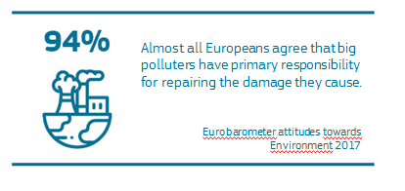

**External costs of transport in the EU are very significant**

The European Commission has been undertaking a study on the internalisation of external costs regarding all modes of transport and covering congestion, accidents, CO2 emissions, noise, air pollution, habitat damage and comparing these costs to the costs paid by users. The objective is to assess the extent to which the "user pays" and "polluter pays" principles are implemented in the EU, and to identify options for further internalisation of the negative externalities. According to preliminary results, the overall level of external costs in transport in the EU Member States is estimated at around EUR 1000 billion annually, corresponding to almost 7% of GDP. The findings of this study, due to be completed by mid-2019, will be an important input for forthcoming debates on the future of EU transport policies.

We also need to ensure that the transition is socially just, that the costs of the transition are equitably split among taxpayers and that everyone pays their fair share. The required shifting of taxes and removal of counterproductive financial incentives such as fossil fuel subsidies can have regressive implications and hit the poor harder. Policy-makers must therefore activate all relevant levers and in addition to, for example, active labour market measures and education and training, ensure that the shift goes hand-in-hand with measures that make fiscal systems and the tax mix more progressive and take into account the most vulnerable groups.[65]

When moving forward, harmonised taxation on negative social and environmental externalities in the EU Single Market will also be important to enable the EU to shift towards a more efficient and sustainable economy and ensure a level playing field for businesses.[66] For example, today the EU’s legal framework for energy taxation still contradicts the EU’s environmental and climate change goals,[67] having a detrimental effect on the agreed policy objectives. Moving away from unanimity voting in the Council, in line with the Commission Communication “Towards a more efficient and democratic decision making in EU tax policy”[68] will be a necessary condition for change.

In addition, competition is an important part of the overall policy mix and of the sustainability transition. Competition policy contributes to “economic democracy” and equality. It enables affordable prices, quality and choice, and curbs entrenched economic power not maintained on merits. Evidence[69] shows that competition policy relatively favours poorer households over richer households and leads to a more efficient allocation of resources as well as driving innovation, notably at the technological frontier.

**Box:** The EU State Aid policy, especially since its modernisation in recent years, has been geared towards sustainability. 94% of total State Aid in the EU was targeted at horizontal objectives of common interest, such as environmental protection, research, development, innovation and regional development. Of total spending, 54% was in support of environmental and energy savings.[70]

### Responsible business conduct, corporate social responsibility and new business models

Businesses have a vital role to play in the sustainability transition. Over the last decades, both on a voluntary basis and spurred on by public authorities, an ever-growing number of companies have made environmental and social responsibility a core part of their corporate missions. More and more companies see the SDGs as an integral part of their competitiveness and growth strategy. They have understood that responsible business can lead to more sustainable profits and growth, new market opportunities, and long-term value for shareholders.

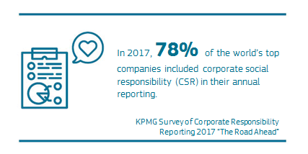

Given the growing complexity and globalisation of supply chains, it is important to promote the application of high sustainability standards also in third countries. Business practices, consumption and production patterns by EU businesses and consumers should not contribute indirectly to human rights violations or environmental degradation elsewhere in the world.

In the last two years, the EU has strengthened the rights of shareholders[71] and investors[72] helping them to understand both the financial and non-financial aspects of companies’ performance and to enable them to better hold companies to account. The EU has also implemented new environmental and social criteria in its public procurement legislation to encourage companies to develop socially responsible products and services. The EU has adopted the Conflict Minerals Regulation[73] to ensure that EU companies import certain minerals and metals only from responsible sources that do not use profits to fund armed conflicts. In this context, the recently adopted Action Plan on Sustainable Finance is relevant too as it connects the finance system with more sustainable projects.[74]

However, there is clearly space to do more at all levels. At EU level, working to identify a number of appropriate measures and tangible ways in which more sustainable business conduct can be promoted bring further results and reinforce the EU companies’ competitive edge in this area. We will have to reflect on different forms of additional incentives for businesses to integrate SDGs in their operations, including exploring the potential of emerging technologies and the circular economy. Both in its internal and external action, the EU will need to continue to promote the implementation of internationally agreed guidelines and principles on responsible business conduct such as the UN Guiding Principles on Business and Human Rights. This is also important in order to ensure an international level playing field.

Looking forward, the collaborative economy – where consumers can deal with each other directly – can make an important contribution to sustainable growth and the emergence of more sustainable business models when encouraged and developed in a responsible manner. At present the patchwork of different regulatory responses across the EU, however, creates uncertainty for traditional operators, new services providers, and consumers alike and hampers the growth of the collaborative economy in the EU and the new and innovative services that are associated with it.

Social entrepreneurship – aimed at solving community based problems, – can play an important role as well in addressing sustainability challenges, while fostering inclusive growth and job creation locally, shared prosperity, and social inclusion. Current social enterprises tend to be concentrated in specific niches – in particular in local contexts, – and struggle to scale up in the EU. Financing remains a significant issue, which is why the EU is dedicating more funding to social enterprises. As with the collaborative economy, the complex or missing regulatory framework and local-level restrictions can be an obstacle. In France, for example, a dedicated legal framework, put in place in 2014 recognised the specificities of the sector and gave a new impetus to these enterprises.

### Open and rules-based trade

Open and rules-based trade is one of the best tools to increase our prosperity and that of our partners, raise our standards of living and the sustainability of our planet and our democracies. If we want to be successful in achieving a sustainable Europe in a sustainable world, it is important to use our multilateral institutions and bilateral and multilateral trade agreements to shape global standards.

Protectionist trends and a 'my country first' approach are prone to induce conflicts. Moreover, they are great obstacles to building a sustainable planet – typically an objective that requires international cooperation. For many reasons it is in the EU’s vital interest to robustly support and sustain the multilateral system.

In the context of the sustainability transition we must work even more actively with like-minded partners to negotiate progressive new rules that take into account the United Nations 2030 Agenda. The latter recognises the key role of the rules-based multilateral trading system, with the World Trade Organization (WTO) at its core, in contributing to the SDGs. The EU’s ongoing constructive efforts to modernise the WTO are therefore essential.

Where current powers are reneging on international trade deals, opportunities arise for the EU. This Union with the most developed internal market in the world and with close to half a billion consumers can step in where others step out, and it has done so. Moreover, it puts trade on a new and more sustainable footing. All new EU trade and investment agreements now include a chapter on sustainable development that upholds and promotes social and environmental standards. The Economic Partnership Agreement signed with Japan in July 2018 is the first agreement to elaborate on the commitments made under the Paris Climate Agreement. In September 2018, the EU and Canada agreed to work on trade and climate change in the framework of the Comprehensive Economic and Trade Agreement (CETA). The EU is negotiating gender-specific provisions in the modernisation of our Association Agreement with Chile.

Box: The Juncker Commission has adopted or started implementing eight trade agreements with 15 countries, including Canada, Ukraine, Singapore, Vietnam, Japan and several African and Pacific countries[75]. The EU now has 39 EU trade agreements in place with 70 countries around the world. Provisions on trade and sustainable development have been at the heart of the EU free trade agreements since 2010.

The Commission proposed 15 points to enhance the implementation and enforcement of the Trade and Sustainable Development chapters in EU trade agreements.[76] The focus is on stronger cooperation with different actors, more effective enforcement, including more assertive use of sustainability chapters in the existing dispute settlement mechanism, and improved communication and transparency.

As part of its efforts to support developing countries, the EU grants unilateral trade preferences under the Generalised Scheme of Preferences. These preferences are conditional on beneficiary countries’ compliance with implementation of core international conventions and agreements concerning human and labour rights, environmental protection and good governance, and hence create an incentive for developing countries to build their economic growth models on sustainable grounds. In case of serious and systematic violations of the principles of these conventions, the Commission can temporarily withdraw these preferences.

### Governance and ensuring policy coherence at all levels

True sustainability change for the benefit of all Europeans through achieving the SDGs requires a comprehensive approach. The EU, its Member States and its partners need to take into account the interlinkages between the different sustainability challenges and opportunities, and support coherence between different policy areas, sectors and levels of decision-making.

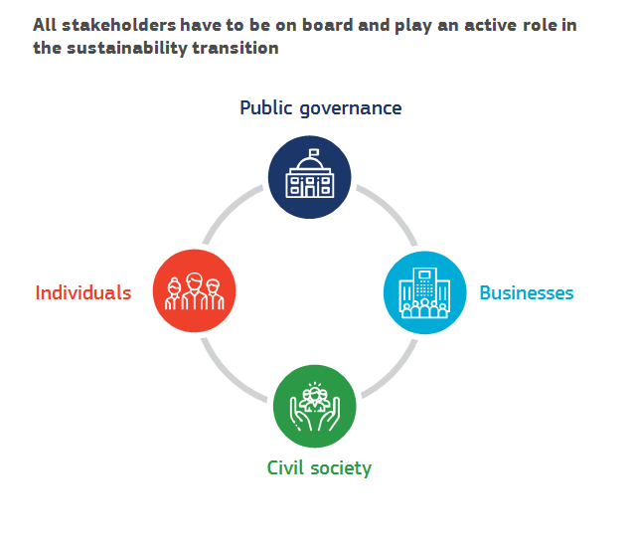

Respect for the rule of law, democracy and fundamental rights are ‘who we are’. These are the non-negotiable principles and values, as set out in the EU Treaties, and they form the foundations upon which we build. They are also established as an integral part of the United Nations 2030 Agenda and the SDGs. The same applies to the principles of peace, justice and robust institutions for which the EU has always been a strong advocate. These principles and common values are not self-executing and the EU, its Member States, and in fact all Europeans need to uphold, maintain and strengthen them. Social partners have an important contribution to make. This partnership needs to be maintained and strengthened in order to ensure both effective governance and adequate policy coherence.

Beyond these underlying principles, policy coherence across the board is essential, grounded in planning, evidence-based policies, inclusiveness, effectiveness, respect for subsidiarity and proportionality, and measurement and monitoring. Better Regulation and better governance at all levels are vital too in this regard. Thorough impact assessments are necessary for all policy options, and trade-offs between the economic, social and environmental policy objectives need to be minimised and mitigated. Related implementation gaps jeopardising sustainable policy coherence should also be addressed in an effective and structural manner.

The SDGs are designed to be indivisible, and most SDGs cover several policy areas. Therefore, better cooperation across administrations needs to be accompanied by better coherence across different policy areas. Food, energy and water resources management are strongly related. The same applies to transport, air quality and health, for example. A so-called ‘nexus’ approach requires multi-sector projects at all levels that address the interlinkages between the SDGs. The European Commission has been following this approach by adopting an internal working method that breaks through silos between Commissioners and all Commission staff.

Policy coherence does not only apply at the internal level, but also to the impact of internal policies on the external dimension, and vice-versa. We must make sure not to export our ecological footprint or create poverty, inequality and instability in other parts of the world. As Europeans we are patently aware that negative impacts elsewhere will in turn have a boomerang effect on our own economy and society, for example by exacerbating the causes of migration. The EU is committed to policy coherence for development, which ensures that the impact of the EU’s internal policies on developing countries is systematically taken into consideration. Relevant monitoring has been integrated in the overall Commission’s follow-up to the United Nations 2030 Agenda.[77]

Successful policies need to set clear and measurable objectives, so that progress can be tracked, and results made publicly available. An agreement on such targets and a monitoring system could be created as a next step at EU level. The European Council welcomed the intention of the Commission to publish this Reflection Paper to pave the way for a comprehensive implementation strategy of the United Nations 2030 Agenda in 2019, which could incorporate this exercise.

Implementing the SDGs also requires effective cooperation at EU, national, regional and local levels. The recommendations of the Commission’s Communication “The principles of subsidiarity and proportionality: Strengthening their role in the EU's policymaking” that followed the ‘Task Force on Subsidiarity, proportionality and doing less more efficiently’ provide a roadmap for achieving this.[78] The Commission and other EU bodies could in particular facilitate an exchange of best practices among cities and regions, and set out the parameters for a cross-border territorial approach for delivering on the SDGs.

Civil society, the private sector and academia must of course also be part of the conversation and the implementation measures. The High Level Multi-stakeholder Platform on the SDGs, established by the European Commission in 2017,[79] has been a positive exercise for bringing together cross-cutting ideas. The Platform's input has been invaluable to the Commission’s work and it is annexed to this Reflection Paper. The High Level Expert group on Sustainable Finance is another positive example of cross-sector cooperation that was fundamental for preparing the Commission’s Action Plan on Sustainable Finance.

For complex challenges with a wide range of competing interests, multi-stakeholder partnerships could be further promoted to address the interdependence between the different SDGs.

On the other end, the multi-level governance approach requires that EU efforts are well articulated at the global governance level. In implementing the SDGs we have to deal with many challenges that know no borders. A stronger “outward looking” orientation, in close cooperation with EU's partners from all over the world at all levels, is therefore necessary. At the United Nations, the High Level Political Forum plays a key role, notably in keeping track of progress. The EU as a strong advocate for multilateralism can take the lead in ensuring proper reporting on progress towards the SDGs and insisting on rigorous implementation and monitoring by all partners.

# The EU as a global trail blazer in sustainable development

The EU and the United Nations are natural partners in the efforts to shape a safer and better world for all. We do not need more walls, but global rules respected by all. The rules-based system is the best guarantor for the sustainability of our economy and society. Only multilateral diplomacy can lead to solutions to international challenges. The EU Global Strategy for the EU’s Foreign and Security Policy recognises the importance of the SDGs as a cross-cutting priority, and concerted efforts are needed by the EU and its Member States in their dealings with the rest of the world.

With the global resurgence of violent conflicts, particularly so in the last five years, we are again reminded that peace and security in the EU also depend on the EU’s ability to contribute to building and sustaining peace elsewhere in the world. The EU's experience in building peace at home gives it the soft power and credibility as a global actor for sustainable peace and prosperity.

The EU must also continue sharing sustainable solutions to global problems as our policies will have only a limited impact on the planet if others pursue opposing policies. By helping and encouraging others to follow our actions, the EU can push for a level playing field, where all compete under the same conditions. Furthermore, sharing EU solutions abroad leads to more jobs and higher sustainable growth, not only in partner countries, but also within the EU itself.

Ultimately, to be most successful in the green and inclusive economic transition, we have to get our global partners on board too and make the case that a global sustainable development model based on our core values and principles is the best way to achieve shared prosperity and a sustainable world. The EU’s internal work on the SDGs and its external projection are therefore two sides of the same coin. It is in the EU’s interest to play a leading role in the implementation of the United Nations 2030 Agenda also globally through its external action.

The EU and its Member States are the largest donor of development and humanitarian assistance worldwide. The EU is collectively committed to increase its contribution of official development assistance to at least 0.7% of the EU’s gross national income a year. Through cooperation with 150 partner countries across the globe, the EU’s development cooperation is both a means to lift people out of poverty and ensure dignity and equality, but also to create peaceful, just and inclusive societies. The protracted nature of crises calls for the EU to continue its concerted effort to simultaneously address humanitarian needs and combat the root causes of poverty, displacement, fragility and instability.

The new European Consensus on Development explicitly gears EU action towards the implementation of the United Nations 2030 Agenda, with the primary objective of eradicating poverty. One of its key strengths is that it is a joint commitment by the EU and all its Member States to work better together, including through more joint programming and more effective coordination on the ground. This new orientation should further improve with the future EU external financing instrument, expressly designed to support the implementation of the SDGs.

We will continue our active engagement with partner countries through policy dialogues based on the SDGs, accompanied by our financial assistance and development cooperation. The EU's new partnership with the countries of Africa, the Caribbean and the Pacific that will succeed the current Cotonou Agreement should work towards increased prosperity by fulfilling the SDGs. When moving forward, building a strong partnership and cooperation with Africa on an equal footing should be of particular importance of the EU and its Member States. The EU has a strong interest in an African continent that thrives economically and politically, with enhanced opportunities for growth, local employment, new business models and mutual beneficial trade relations with Europe. In parallel, the EU's engagement with more advanced developing countries in a broad range of sectors can have a significant impact on global sustainable development.

Getting the private sector fully on board and boosting sustainable investment also beyond the EU's borders remains a priority. The European External Investment Plan has created a new standard in the use of public funding to leverage private investment for sustainable development in partner countries – starting with Africa and the EU's Neighbourhood.[80] The new Africa-Europe Alliance for Sustainable Investment and Jobs, launched in September 2018 holds great potential for unlocking sustainable investments, with the perspective of creating up to 10 million jobs in Africa in the next five years alone.

As developing countries in particular face difficulties in accessing adequate finance for their needs in sustainable infrastructure and energy efficiency, the global nature of financial markets could offer great potential in supporting all countries on their transition path by bridging local needs with global sources of funding. Aligning sustainable finance initiatives and tools across jurisdictions would ensure compatible markets for sustainable financial assets across borders, achieving economies of scale and avoiding fragmentation. This would bring new major investment opportunities for businesses and the financial sector worldwide.

The EU aims to be at the forefront of coordinating international efforts towards building a financial system that supports sustainable growth globally. To enhance cooperation and exploit synergies, it would be opportune to establish an international network of jurisdictions from both developed and developing countries that are committed to advancing sustainable finance. A coherent international strategy and architecture, leveraging the efforts of institutions such as the World Bank Group, the Organisation for Economic Co-operation and Development, the European Investment Bank, and the European Bank for Reconstruction and Development, would contribute to scaling up sustainable finance and mobilising international investors towards sustainable investments across the globe. New financial technologies and innovative financing solutions offer additional great opportunities to link global investors with sustainable projects.

Climate change and environmental degradation are increasingly one of the biggest threats to peace and security in the world and without decisive action they will become an even greater source of global risk, including forced displacement and migration. The EU needs to lead the way, including in the rigorous implementation of the Paris Climate Agreement and in pursuing international efforts to decarbonise the transport sector. The EU could also initiate binding global agreements in the areas of circular economy, resource use and biodiversity.

Being the first mover in the green and inclusive economic transition, combined with a strong push for international rules, will allow us to set the standards for the world and give us a strong competitive advantage in the global marketplace.

# Scenarios for the future

The EU has fully committed itself to delivering on the United Nations 2030 Agenda and its implementation. With a new five-year policy cycle on the horizon, it is time to agree how we live up to our collective commitment. The EU institutions need to decide on the structures, tools and policies they will deploy to implement and achieve the SDGs, and to help and guide our partners. There are different ideas on how best to achieve this, and each institution, Parliament, Council and the Commission, has its own responsibilities in line with the Treaties and our international commitments.

In October 2018 the European Council welcomed the intention of the Commission to publish a Reflection Paper to pave the way for a comprehensive implementation strategy in 2019.

This Reflection Paper puts forward three different scenarios following the European Council’s guidance to lead the discussion on how the implementation of the SDGs could best be achieved and what would be the most effective division of roles. This reflection is intended to inform a debate among citizens, stakeholders, governments and institutions in the months ahead, with a view to inspire the preparation of the EU Strategic Agenda 2019-2024 and the priority setting of the next President of the European Commission.

All three scenarios rely on a shared premise that there is a broad recognition by EU Member States, businesses and civil society that enhanced commitment is needed if the EU and the world are to secure a sustainable future and achieve the SDGs by 2030 and beyond in the interest of a modern economy, a clean environment, and the well-being of our citizens whilst we secure a habitable planet.

There is also agreement that while sustainability action necessitates a European scale, ultimately we can only truly succeed by a global approach. Furthermore, for the EU to continue to thrive as a prosperous continent, significant parts of the developing world need support to catch up economically and socially. In the same vein, supporting the economic progress of developing countries towards the SDGs also contributes to a broad range of EUs strategic interests, such as reducing irregular migration. The SDGs, as signed by 193 states, offer the best and most modern global and comprehensive framework to base our work on.

The European debate is now on what to do and how to do it. The three scenarios outline different responses but depart from the notion that the EU has great competitive advantages to lead globally and be a successful first mover. These scenarios are neither restrictive nor prescriptive. They aim to offer different ideas and spur debate and thinking. The eventual outcome would likely be a combination of certain elements from each.

**Scenario 1: An overarching EU SDG strategy to guide the actions of the EU and its Member States**

One step to respond to the challenges we face is to endorse at the highest EU political level the globally agreed SDGs as the overarching strategic policy objectives for the EU and its Member States. Such an approach would be in line with the recommendation of the High Level Multi-stakeholder Platform on the SDGs.

Under this scenario, the United Nations 2030 Agenda and the SDGs would be our compass and map and thus determine the strategic framework for the EU and its Member States.

Strategic action by the EU and the Member States, including regional and local authorities, would be pursued and effectively coordinated. A joint approach at all levels of government would be stimulated, in close cooperation with all stakeholders. This would include a strong component in the EU’s relations with third countries to further international sustainability action.

This also implies the establishment of a 'European process for SDG policy coordination' to regularly assess and monitor progress in implementation, reflecting the cross-cutting nature and inter-connectivity between the SDGs, including in the internal governance of the European Commission.

| **What this could mean in practice** |
| --- |
| * Specific SDG implementation targets are defined at EU level and an overarching EU SDG Strategy is implemented by the Commission, the European Parliament and the Council; * Comprehensive national SDG strategies are developed at national level; * Concrete and time-bound deliverables for 2030 are proposed by the Commission and endorsed by the European Council; * The “sustainability first” principle is integrated into the Better Regulation Agendas of the EU and its Member States; * A mechanism of reporting and monitoring of SDG progress at EU and Member State level is established and coordinated, for instance in the context of the European Semester; * The role of the Multi-stakeholder Platform on the SDGs is strengthened with a specific role in the monitoring of the implementation of the SDGs; * The EU further strengthens its external action on sustainability and gears all external policy actions towards the implementation of the SDGs. |

|  |
| --- |
| **Pros and Cons** |
| * Creating a strong common positive vision for the sustainable future of Europe across the EU; * Strengthening political ownership and enhancing coordination across all levels of governance within the EU and, given the cross-border nature of the identified EU challenges, a better possibility to achieve the United Nations 2030 Agenda and green and inclusive growth for the EU; * Providing a strong signal at international level that the EU is fully committed to its international obligations and the United Nations 2030 Agenda and the SDGs, both internally and externally; * Clear and transparent communication and engagement with stakeholders. * Risk that the approach is not tailored enough to the specificities and challenges of individual Member States' as the strategic framework could not take into consideration all the differences; * Given the complexity of agreeing on EU-wide deliverables in all the different areas of the SDGs, risk of dedicating a lot of time on strategy development instead of moving ahead in concrete policy areas at all levels that would make a difference. |

**Scenario 2: Continued mainstreaming of the SDGs in all relevant EU policies by the Commission, but not enforcing Member States’ action**

Under this scenario, the SDGs will continue to inspire our political decision-making with regard to the EU’s policy making, and guide the development of the post-EU2020 growth strategy, while not binding EU Member States to achieving collectively the SDG commitments in the EU.

In the European Commission this could mean that a member of the College is granted a broad responsibility for 'sustainability'. This Commissioner could continue working together with other Commissioners in a dedicated project team involving all the Commissioners. To ensure policy coherence, close cooperation with other project teams of Commissioners would have to be sought.

Through its Better Regulation Agenda, the Commission would continue pursuing an inclusive and evidence-based decision-making process. Combined with stronger SDG mainstreaming of the European Semester in line with the post-EU2020 growth strategy, the EU's policy coherence is reinforced and it is ensured that the EU moves closer to the SDGs.

However, this approach would leave more freedom to Member States, and regional and local authorities as to whether and how they adjust their work to delivering in a consistent manner on the SDGs.

| **What this could mean in practice** |
| --- |
| * Using the SDGs to guide the development of the post-EU2020 growth strategy, focussing on areas with most EU added-value, such as circular economy; research and innovation; employment and social inclusion; climate and energy; food systems, farming and land use; and cohesion policy; * Mainstreaming the SDGs through EU policies and actions, through the Better Regulation Agenda, adapted to fit the specific EU context with shared competences with Member States; * Using the Multiannual Financial Framework (MFF) to provide part of the necessary additional funding for delivering on the sustainability mainstreaming approach; Member States commit to doing the same; * The SDGs and relevant EU targets are included in the European Semester process where relevant to the post-2020 growth strategy; * If and once the EU Free Trade Agreements are modernised and future trade agreements are negotiated, the trade and sustainability chapters are reinforced where necessary and effectively enforced; * The EU monitors the SDG implementation through the Eurostat SDG progress analysis, which will continue to be developed. Member States prepare annual national monitoring reports; * Member States retain the key responsibility for reporting on SDG implementation, with a complementary EU reporting from European Commission on SDG progress at international level to the UN High Level Political Forum on Sustainable Development. |
| **Pros and Cons** |
| * Since the most critical areas for the EU for achieving the SDGs are broadly clear, EU can focus on setting strategic priorities and delivering concrete results in the areas with most EU added value; * EU level decision-making is quicker and the negotiations on strategic priorities more consensual; * The EU continues to be a global advocate for the United Nations 2030 Agenda and the SDGs. * Policy coherence for sustainable development between EU policies and between EU and national policies would be more difficult to ensure; * Risk that fulfilment of sustainability commitments by the EU and its Member States as a whole cannot be accomplished and Member States’ action cannot be enforced; * Individual Member State actions in certain key areas, instead of stronger coordinated EU-level action, could affect the single market and global competitiveness; * Risk that a gap could open up between the EU’s political commitment to the SDGs and its effective output. |

**Scenario 3: Putting enhanced focus on external action while consolidating current sustainability ambition at EU level**

External action would be prioritised in the context of the SDGs. As the EU is already a frontrunner in many aspects related to the SDGs, enhanced focus could be placed on helping the rest of the world catch up, while pursuing improvements at EU level.

Our social market economy has become an EU trademark, and has allowed the economies of the EU Member States to generate wealth and broad-based prosperity thanks to strong social welfare systems. The EU has some of the world's highest environmental standards already, and our businesses are ahead of the curve compared to global competitors. The EU is also seen as a stronghold for freedom and democracy, with stable institutions based on the rule of law and a vibrant civil society. The EU could therefore decide to promote more strongly its current environmental, social and governance standards through multilateral negotiations and trade agreements.

The EU could also further intensify its collaboration with key international organisations and forums, such as the United Nations, including the International Labour Organisation, the World Trade Organisation, and the G20 as well as the supervisory bodies of multilateral environmental agreements, to advance the EU’s values-based external policy agenda.

The EU's stance in support of multilateralism – with the United Nations at its core – and transparent and reliable international relations would continue to be prioritised.

| **What this could mean in practice** |
| --- |
| * Mainstreaming of SDGs in EU external policies continues, recognising different needs and interests of partners, while internal adjustments are more limited; * The EU provides regular detailed reporting and monitoring of SDG progress on the external action of the EU at international level in the United Nations; * If and once the EU Free Trade Agreements are modernised and future trade agreements are negotiated, the trade and sustainability chapters are reinforced where necessary and effectively enforced; * The implementation of the Global Strategy for the EU’s Foreign and Security Policy and of the new European Consensus on Development is reinforced; * Strengthened European defence, space, security and migration policy are promoted as enabling policies for the reinforced external policy agenda for sustainable development; * New forms of sustainable financing and development such as the External Investment Plan are reinforced. |

|  |
| --- |
| **Pros and Cons** |
| * EU concentrates its resources on those countries or regions most in need, while pursuing adjustments to EU policies through SDG mainstreaming, without a dedicated strategic framework; * EU external action is consistent with its objectives to promote sustainability, democracy, human rights, the rule of law and fundamental freedoms in the world. * Risk that this approach would erode the EU's political credibility and leadership on the United Nations 2030 Agenda and the SDGs at home and globally, at a time when multilateralism is under strain. One of the key features of the United Nations 2030 Agenda, which the EU actively promoted, is that it is universal; * The EU misses out on the possibility to develop a positive vision for the future of Europe centred on sustainability; * The EU does not use the first-mover advantage to establish EU sustainability standards for the world to follow and risks that the benefits of sustainable growth are reaped by others in the global marketplace; * The consolidation of the current EU SDG policy approach risks not meeting citizens’ evolving expectations and ambitions. |

1. UN Secretary-General Ban Ki-moon at the summit for the adoption of the post-2015 development agenda, in New York, 25 September 2015. Available at: <https://www.un.org/press/en/2015/sgsm17111.doc.htm>
2. OJ C 202, 7.6.2016.
3. My Region, My Europe, Our Future: Seventh report on economic, social and territorial cohesion, 2017.

   Available at: <https://ec.europa.eu/regional_policy/sources/docoffic/official/reports/cohesion7/7cr.pdf>.
4. World Happiness Report 2018, by John F. Helliwell, Richard Layard and Jeffrey D. Sachs.
5. Eurostat, quality of life indicators. Available at: <https://ec.europa.eu/eurostat/statistics-explained/index.php/Quality_of_life_indicators>
6. European Youth Forum, Youth Progress Index 2017. Available at: <https://www.youthforum.org/youth-progress-index>.
7. Annex 3 to the Reflection Paper highlights in more detail the major initiatives of the Juncker Commission contributing to the United Nations 2030 Agenda and Paris Agreement on Climate Change.
8. COM(2018) 773 final.
9. COM(2010) 2020 final.
10. EUCO 13/18 - European Council meeting (18 October 2018), Conclusions, III.12.
11. COM(2016) 739 final.
12. Annual Growth Survey 2018 COM(2017) 690 final.
13. European Economic Forecast Autumn 2018 published on 8 November 2018. Available at: <https://ec.europa.eu/info/sites/info/files/economy-finance/ip089_en_0.pdf>.
14. Global Footprint Network. Available at: <https://www.footprintnetwork.org/our-work/ecological-footprint/> .
15. EU Commission, Raw Materials Scoreboard 2018.
16. WWF. 2018. Living Planet Report - 2018: Aiming Higher. Grooten, M. and Almond, R.E.A.(Eds). WWF, Gland, Switzerland.
17. European Environmental Agency (2017), "Food in a green light. A systems approach to sustainable food".
18. SWD(2016) 319 final.
19. COM(2019)1.
20. In-depth analysis in support of the Commission Communication COM(2018)773, section 5.6.2.3.
21. Dante Disparte, "If You Think Fighting Climate Change Will Be Expensive, Calculate the Cost of Letting It Happen", 12 June 2017, Harvard Business Review online. Available at: <https://hbr.org/2017/06/if-you-think-fighting-climate-change-will-be-expensive-calculate-the-cost-of-letting-it-happen>
22. Eurostat, Sustainable development in the European Union, Monitoring Report on Progress towards the SDGs in an EU Context, 2018 edition.
23. <https://ec.europa.eu/food/safety/food_waste_en>.
24. Eurostat, Sustainable development in the European Union, Monitoring Report on Progress towards the SDGs in an EU Context, 2018 edition.
25. Eurostat, Sustainable development in the European Union, Monitoring Report on Progress towards the SDGs in an EU Context, 2018 edition.
26. Food and Agriculture Organization of the UN (FAO), 2016, Antimicrobial resistance and our food systems: challenges and solutions. Available at: <http://www.fao.org/3/a-i6106e.pdf>
27. European Institute for Gender Equality (2017), Gender Equality Index 2017 – Measuring gender equality in the European Union 2005-2015, Press Release 11 October 2017. Available at:

    <https://eige.europa.eu/news-and-events/news/gender-equality-index-2017-progress-snails-pace>
28. European Commission, 2018 Report on equality between women and men in the EU.
29. OECD(2015), In It Together: Why Less Inequality Benefits All, OECD Publishing, Paris.
30. International Organisation for Migration, “Migration, Environment and Climate Change: Assessing the Evidence”, 2009.
31. 7th Environment Action Programme. Available at: <https://eur-lex.europa.eu/legal-content/EN/TXT/?uri=CELEX:32013D1386>.
32. Eurostat, Environmental economy – statistics on employment and growth. Available at: <https://ec.europa.eu/eurostat/statistics-explained/pdfscache/10420.pdf>. The environmental economy encompasses two broad groups of activities and/or products: ‘environmental protection’ all activities related to preventing, reducing and eliminating pollution and any other degradation of the environment; ‘resource management’ — preserving and maintaining the stock of natural resources and hence safeguarding against depletion.
33. S. Fankhauser, A. Bowen et al. "Who will win the green race? In search of environmental competitiveness and innovation", 2013.
34. Business and Sustainable Development Commission, "Better Business Better World, The report of the Business & Sustainable Development Commission", January 2017 (p. 12).
35. EU Environmental Implementation Review 2017.
36. Among others: Intergovernmental Panel on Climate Change “Global warming of 1.5 °C: an IPCC special report on the impacts of global warming of 1.5 °C above pre-industrial levels and related global greenhouse gas emission pathways, in the context of strengthening the global response to the threat of climate change, sustainable development, and efforts to eradicate poverty”, 2018; Sachs, J., Schmidt-Traub, G., Kroll, C., Lafortune, G., Fuller, G. (2018): SDG Index and Dashboards Report 2018. New York: Bertelsmann Stiftung and Sustainable Development Solutions Network (SDSN); Europe moving towards a sustainable future, Contribution of the Multi-Stakeholder Platform on the implementation of the Sustainable Goals in the EU Reflection Paper, October 2018.
37. Eurostat, Sustainable development in the European Union, Monitoring Report on Progress towards the SDGs in an EU Context, 2018 edition.
38. *“*Growth within: A circular economy vision for a competitive Europe”, Ellen MacArthur Foundation and the McKinsey Center for Business and Environment, 2015.
39. Towards a circular economy – Waste management in the EU, 2017, European Parliamentary Research Service
40. SITRA, The circular economy - a powerful force for climate mitigation, 2018. Available at: <https://www.sitra.fi/en/publications/circular-economy-powerful-force-climate-mitigation/>.
41. COM/2018/028 final.
42. COM/2018/340 final.
43. Business and Sustainable Development Commission, "Better Business Better World, The report of the Business & Sustainable Development Commission", January 2017.
44. Business and Sustainable Development Commission, "Better Business Better World, The report of the Business & Sustainable Development Commission", January 2017.
45. Food and Agriculture Organization of the UN (FAO), Green jobs. Available at: <http://www.fao.org/rural-employment/work-areas/green-jobs/en/>
46. Eurostat, Sustainable development in the European Union, Monitoring Report on Progress towards the SDGs in an EU Context, 2018 edition.
47. European Commission, Monitoring Agri-trade Policy, MAP 2018-1, “Agri-food trade in 2017: another record year for EU agri-food trade”.
48. Available at: <https://ec.europa.eu/commission/publications/natural-resources-and-environment>.
49. Available at:[https://ec.europa.eu/health/amr/sites/amr/files/amr_action_plan_2017_en.pdf](https://ec.europa.eu/health/amr/sites/amr/files/amr_action_plan_2017_en.pdf%20).
50. In-depth analysis in support of the Commission Communication COM(2018) 773 A Clean Planet for all A European long-term strategic vision for a prosperous, modern, competitive and climate neutral economy.

    Production of meat has one of the largest land requirement per calorie. The shift and reduction in meat consumption will free additional land.
51. The energy efficiency of refrigerators has increased significantly over the last 10 years (the same is true for washing machines, dishwashers, televisions, for example). This also means people are buying more efficient products. Top ten based on GFK data. Available at: [topten.eu](http://topten.eu)
52. COM(2016) 377.
53. Up to 9.6% of Europe’s GDP was devoted to health care in 2017, thus pursuing efficiency in health spending and tackling wasteful spending is increasingly important.
54. COM(2017) 206, Reflection Paper on the Social Dimension of Europe, 26 April 2017.
55. United Nations, Sustainable Development Goals, Goal 11: Make cities inclusive, safe,resilient and sustainable. Available at: <https://www.un.org/sustainabledevelopment/cities/>
56. The Role of Science, Technology and Innovation Policies to Foster the Implementation of the Sustainable Development Goals Report of the Expert Group “Follow-up to Rio+20, notably the SDGs”.
57. COM(2018) 22 final.
58. In November 2018, the European Commission launched AI Watch in order to monitoring AI-related developments in the EU and worldwide and provide necessary analytical basis for further action.
59. European Commission “USA-China-EU plans for AI: where do we stand?” January 2018. Available at: <https://ec.europa.eu/growth/tools-databases/dem/monitor/sites/default/files/DTM_AI%20USA-China-EU%20plans%20for%20AI%20v5.pdf>.
60. Jiaxuan You, Xiaocheng li, melvin low, David B. Lobell, Stefano Ermon, "Sustainability and Artificial Intelligence Lab, Combining Remote Sensing Data and Machine Learning to Predict Crop Yield". Available at: <http://sustain.stanford.edu/crop-yield-analysis>
61. The United Nations Conference on Trade and Development. Available at: http://www.eurasia.undp.org/content/rbec/en/home/blog/2017/7/12/What-kind-of-blender-do-we-need-to-finance-the-SDGs-.html
62. The Action Plan on Sustainable Finance. Available at: <https://ec.europa.eu/info/publications/180524-proposal-sustainable-finance_en>.
63. Business and Sustainable Development Commission, "Better Business Better World, The report of the Business & Sustainable Development Commission", January 2017.
64. Business and Sustainable Development Commission, "Better Business Better World, The report of the Business & Sustainable Development Commission", January 2017.
65. Tax Policies in the European Union: 2018 Survey. Available at:

    <https://ec.europa.eu/taxation_customs/business/company-tax/tax-good-governance/european-semester/tax-policies-european-union-survey_en>. In December 2018, the Commission launched a study looking at megatrends (climate change, digitalization, population aging etc.) and their impact on EU economies, particularly the sustainability of EU tax systems.
66. COM(2019) 8 final.
67. COM(2019) 8 final.
68. COM(2019) 8 final.
69. Dierx, Adriaan, Ilzkovitz, Pataracchia, Ratto, Thum-Thysen and Varga (2017), “Does EU competition policy support inclusive growth?”, Journal of Competition Law & Economics, Vol. 13, No. 2; OECD Factsheet on how competition policy affects macro-economic outcomes (October 2014); Fabienne Ilzkovitz and Adriaan Dierx, “Ex-post economic evaluation of competition policy enforcement: A review of the literature”, DG Competition, June 2015.
70. [http://ec.europa.eu/competition/state_aid/scoreboard/index_en.html](http://ec.europa.eu/competition/state_aid/scoreboard/index_en.html%20) 
71. Directive (EU) 2017/828 of the European Parliament and of the Council of 17 May 2017 amending Directive

    2007/36/EC as regards the encouragement of long-term shareholder engagement (Text with EEA relevance)
72. Directive 2014/95/EU of the European Parliament and of the Council of 22 October 2014 amending Directive 2013/34/EU as regards disclosure of non-financial and diversity information by certain large undertakings and groups (Text with EEA relevance).
73. The Conflict Minerals Regulation (EU) 2017/821.
74. <https://ec.europa.eu/info/publications/180524-proposal-sustainable-finance_en#investment>. A more comprehensive picture of recent EU progress on CSR/RBC and Business and Human Rights will be presented in early 2019 in the context of EU Industry Days.
75. Cameroon, Côte d'Ivoire, Ghana, and the SADC EPA countries Botswana, Lesotho, Mozambique, Namibia, South Africa and Swaziland.
76. Non-paper of the Commission services. Available at: <http://trade.ec.europa.eu/doclib/docs/2018/february/tradoc_156618.pdf>.
77. Progress is outlined in the 2019 EU report on policy coherence for development, published together with this Reflection Paper: European Commission Staff Working Document (2019)20.
78. COM(2018) 703 final. Available at: <https://ec.europa.eu/info/sites/info/files/communication-principles-subsidiarity-proportionality-strengthening-role-policymaking_en.pdf> and [https://ec.europa.eu/commission/priorities/democratic-change/better-regulation/task-force-subsidiarity-proportionality-and-doing-less-more-efficiently_en.](https://ec.europa.eu/commission/priorities/democratic-change/better-regulation/task-force-subsidiarity-proportionality-and-doing-less-more-efficiently_en.%20) 
79. Available at: <https://ec.europa.eu/info/strategy/international-strategies/global-topics/sustainable-development-goals/multi-stakeholder-platform-sdgs_en>.
80. With over EUR 37 billion leveraged since its inception in September 2017, it is well on track to leverage the 2020 objective of EUR 44 billion of investments for sustainable development by 2020.